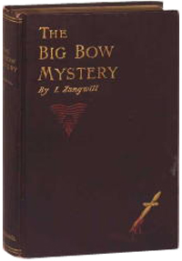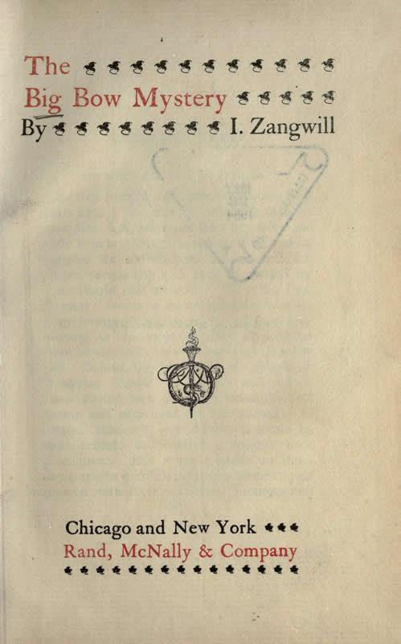

Zangwill, Israel
The Big Bow Mystery
Chicago: Rand, McNally and Co, 1895

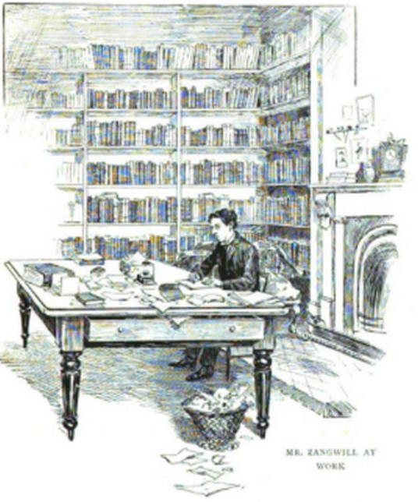

George Wylie Hutchinson

Mr. Zangwill at work

