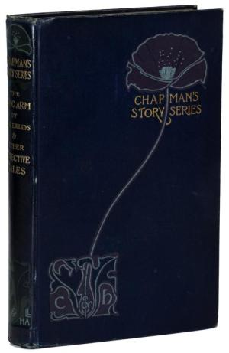

THE LONG ARM

by Mary E. Wilkins

AND OTHER DETECTIVE STORIES

by George Ira Brett, Professor Brander Matthews, and Roy Tellet

Published by Chapman & Hall, Ld., London (1895)

