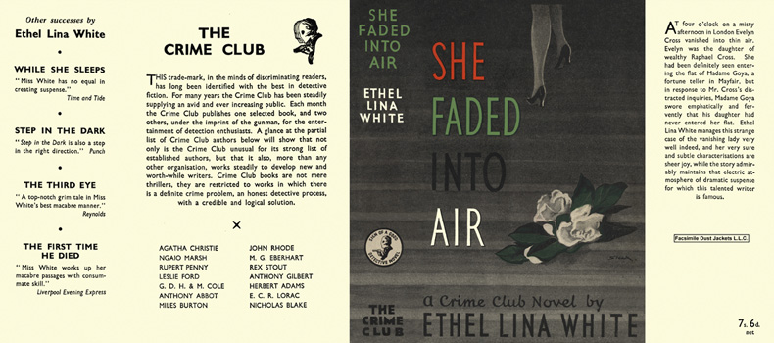

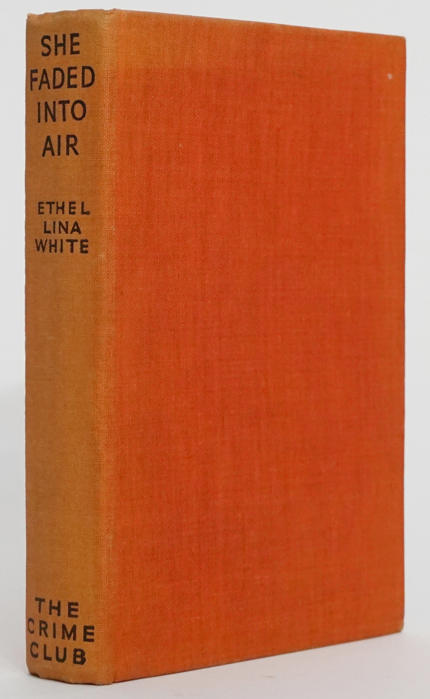

White, Ethel Lina
She faded into air
Collins The Crime Club (UK) (1941) first printing

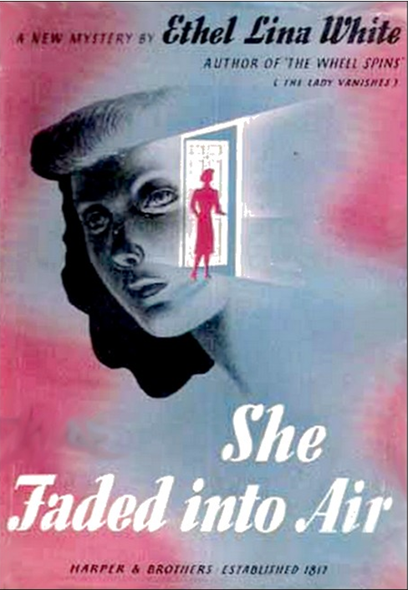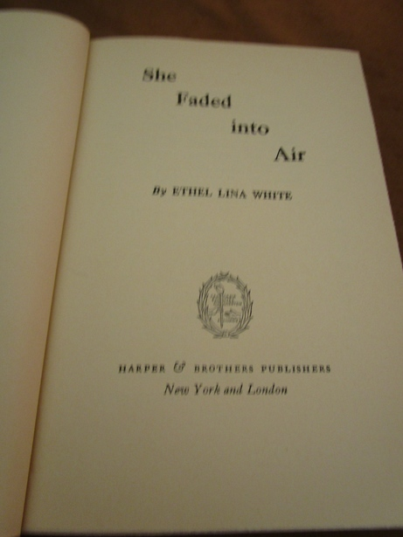

White, Ethel Lina
She faded into air
Harper and Brothers Publishers (USA) (1941) first printing

Суперобложки и внешний вид первых изданий романа

