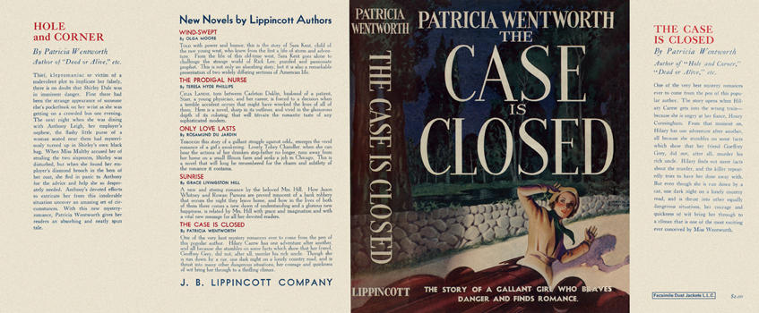

Wentworth, Patricia

The case is closed
J. B. Lippincott Company (USA) (1937) first printing.

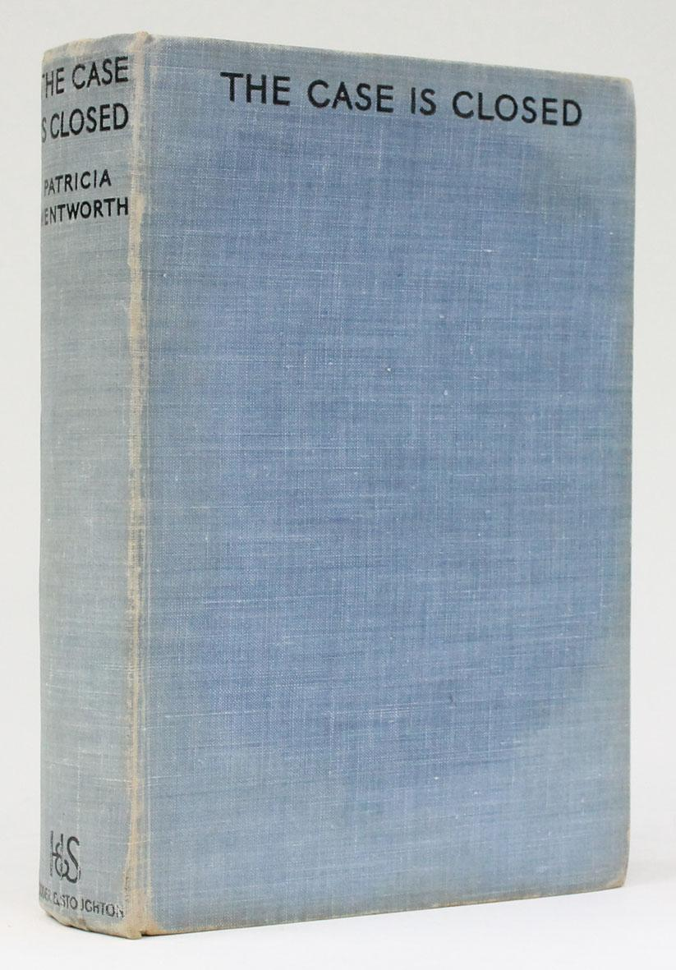

Wentworth, Patricia

The case is closed
Hodder and Stoughton (UK) (1937) first printing

Суперобложка и внешний вид первых изданий романа

