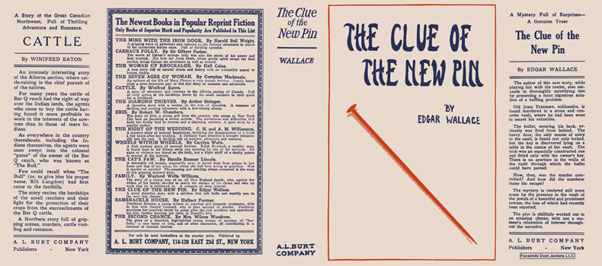

Wallace, Edgar
The clue of the new pin
A. L. Burt Company (USA) (1923)

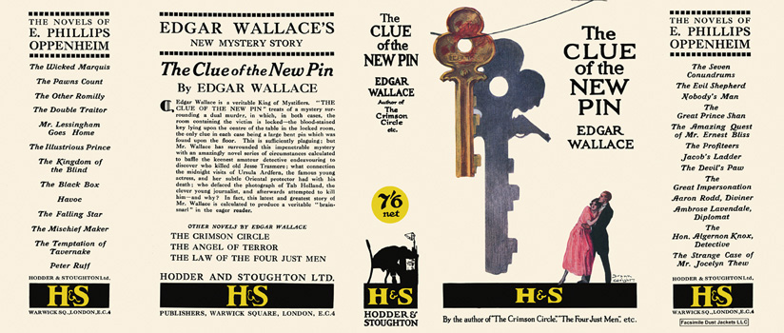

Wallace, Edgar
The clue of the new pin
Hodder & Stoughton (UK) (1923)

Суперобложки первых изданий романа

