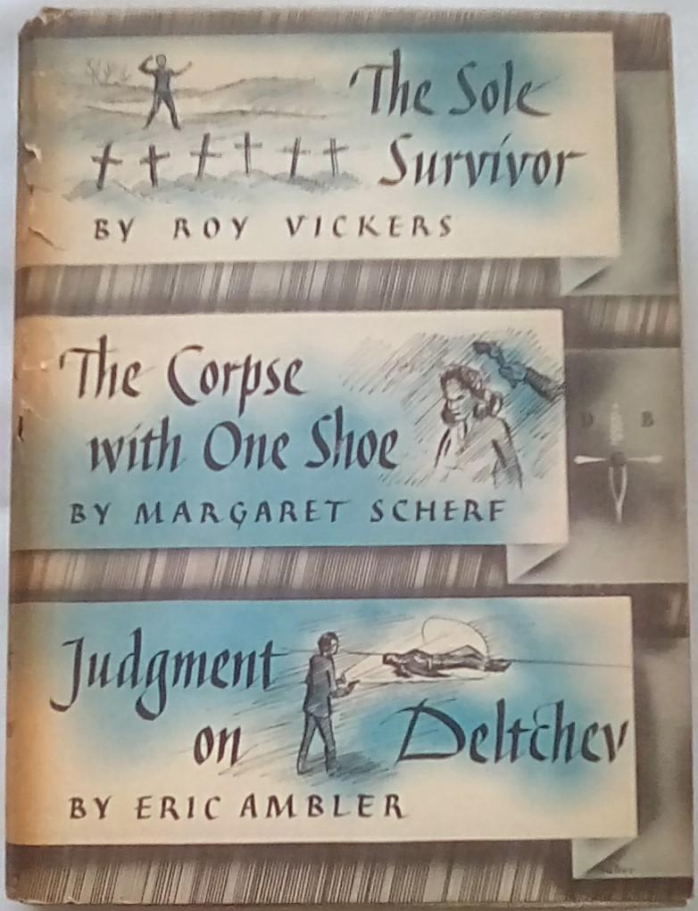

Vickers, Roy

Scherf, Margaret

Ambler, Eric

The sole survivor and The Kynsard affair

The corpse with one shoe

Judgment on Deltchev
Walter J. Black (USA) (1951) first edition



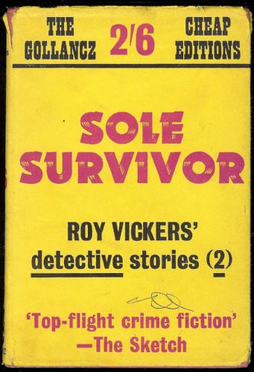
Vickers, Roy
The sole survivor and The Kynsard affair
V. G. Gollancz (UK) (1952) first printing

Обложки первых изданий сборников, в которых была напечатана повесть

