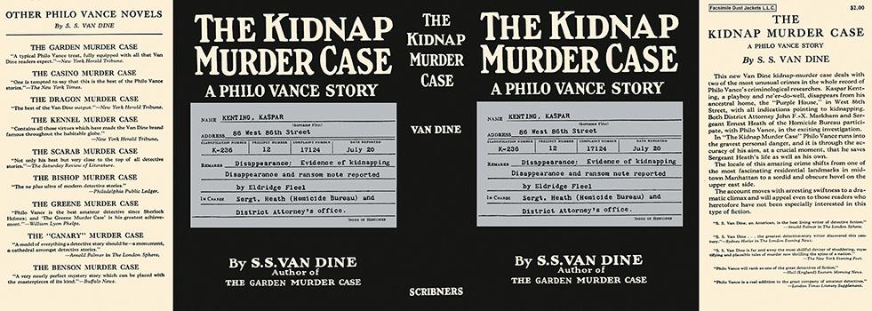

Van Dine, S. S.
The kidnap murder case
Charles Scribner's Sons (USA), 1936
first printing

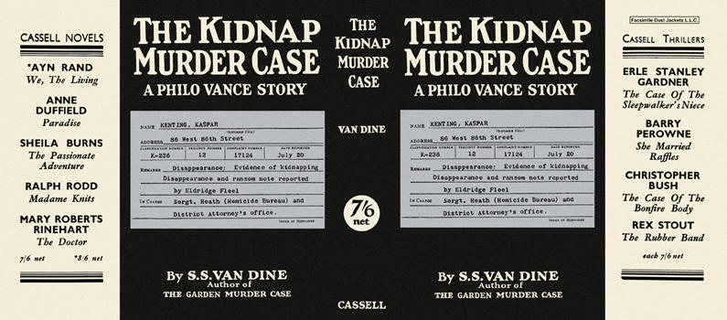

Van Dine, S. S.
The kidnap murder case
Cassell (UK), 1936
first printing

Суперобложки первых изданий книги

