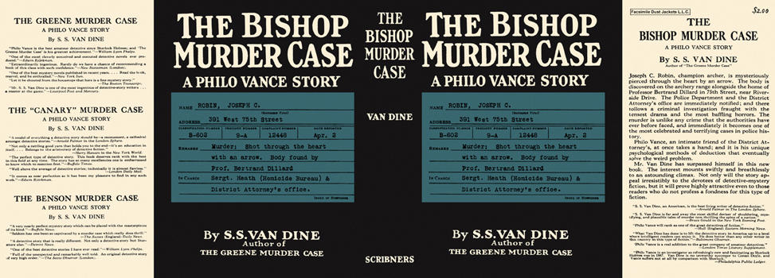

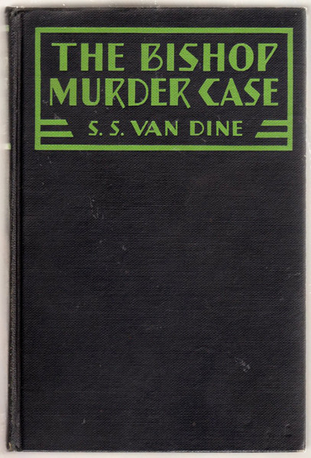

Van Dine, S. S.
The Bishop murder case
Charles Scribner's Sons (USA), 1929
first printing

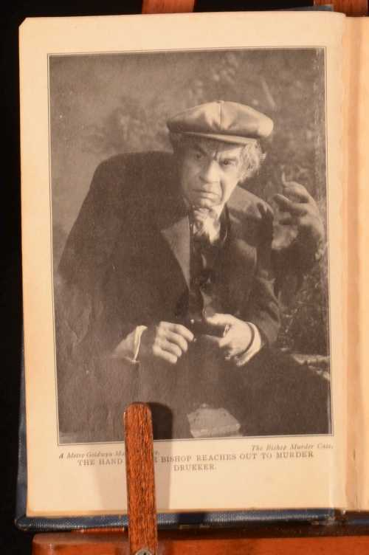

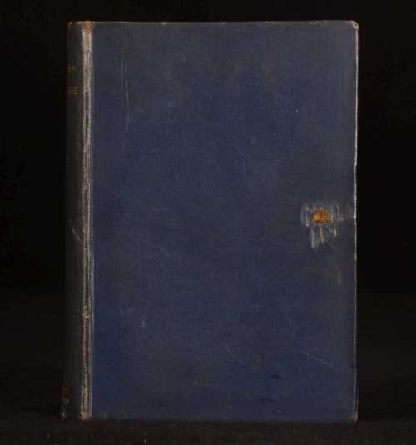

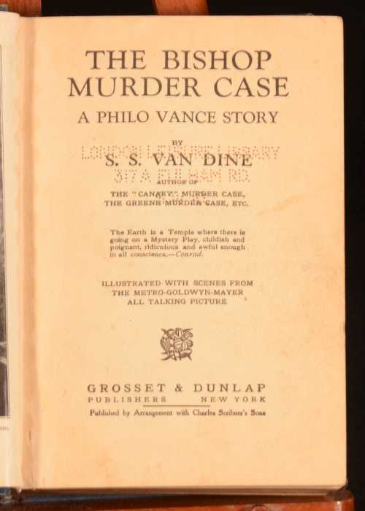

Van Dine, S. S.
The Bishop murder case
New York: Grosset and Dunlap, 1929

Внешний вид первых изданий книги

