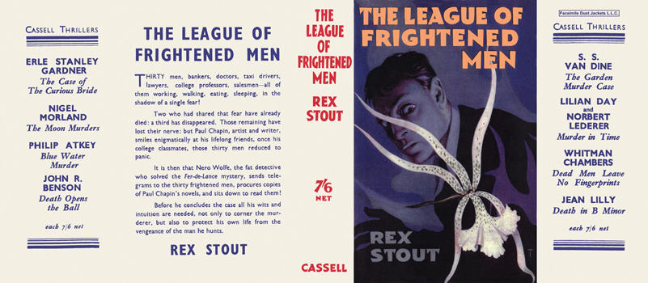

Stout, Rex
The league of frightened men
Cassell (UK) (1935) first printing

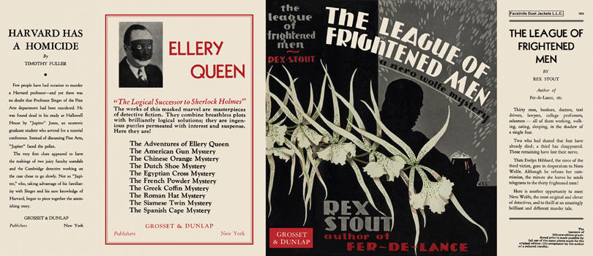

Stout, Rex
The league of frightened men
Grosset & Dunlap (USA) (1935) first printing

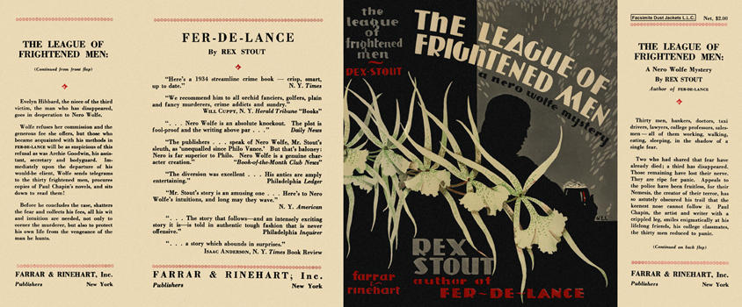

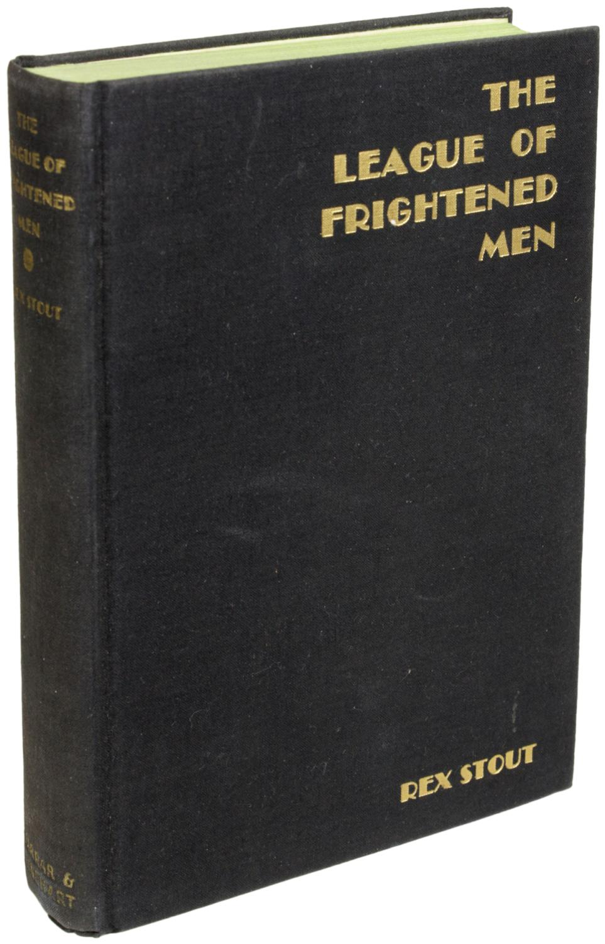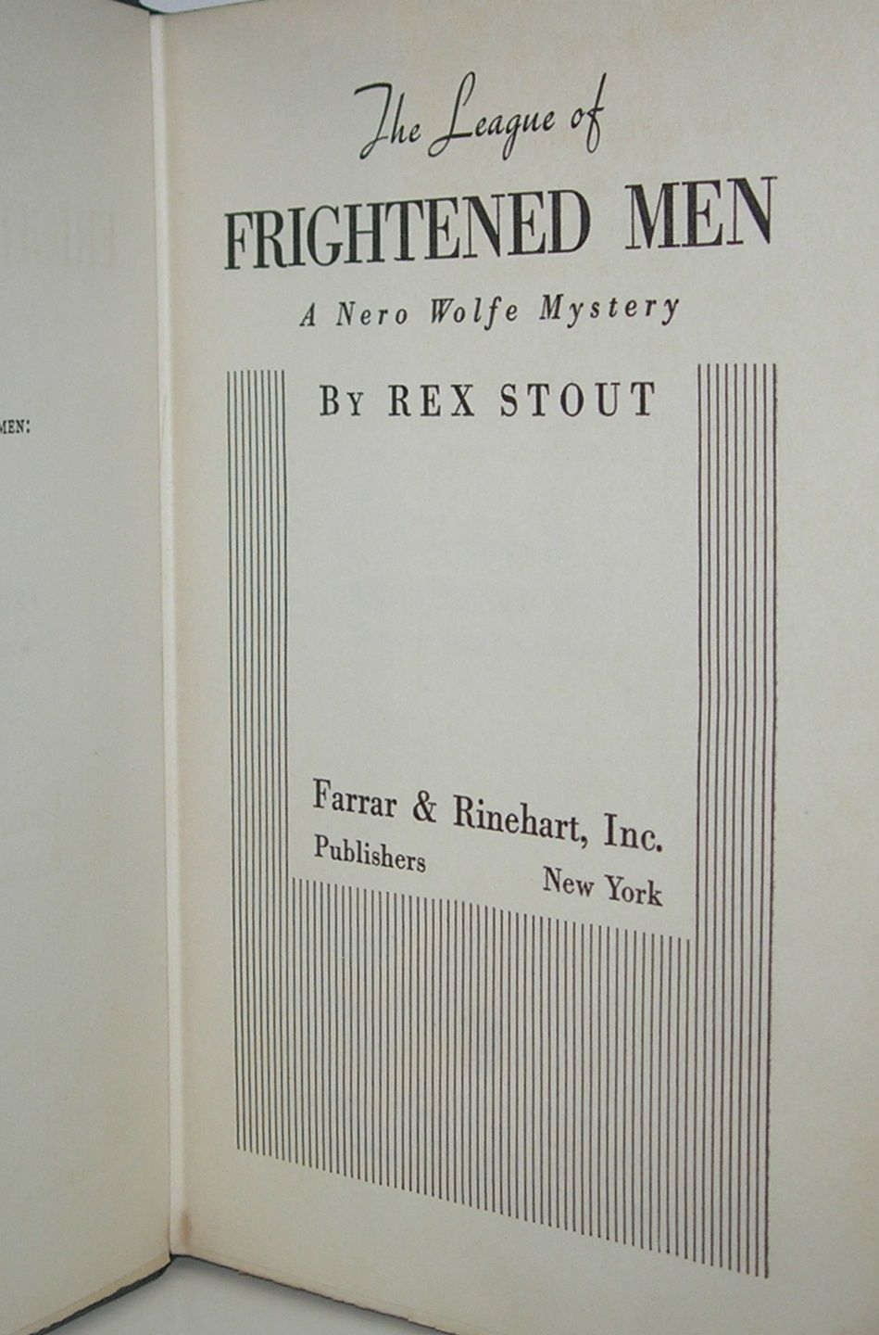

Stout, Rex
The league of frightened men
Farrar and Rinehart, Inc. (USA) (1935) first printing

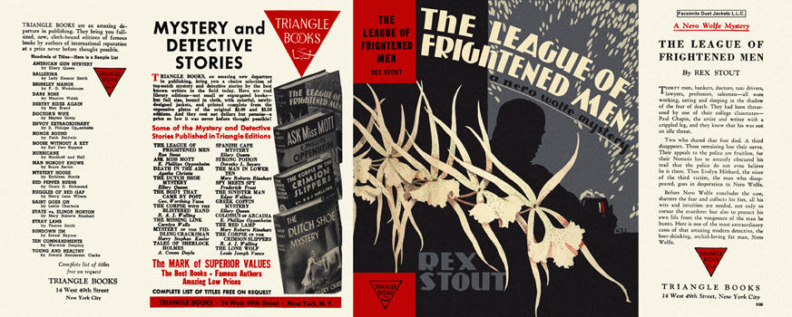

Stout, Rex
The league of frightened men
Triangle Books (USA) (1935) first printing

Суперобложки и внешний вид первых изданий книги

