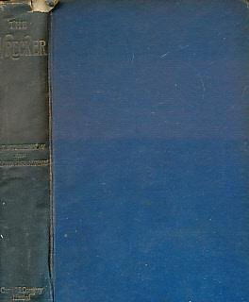

Stevenson, Robert Louis

Osbourne, Lloyd

The Wrecker
Cassell & Co Ltd, London, 1892 first edition

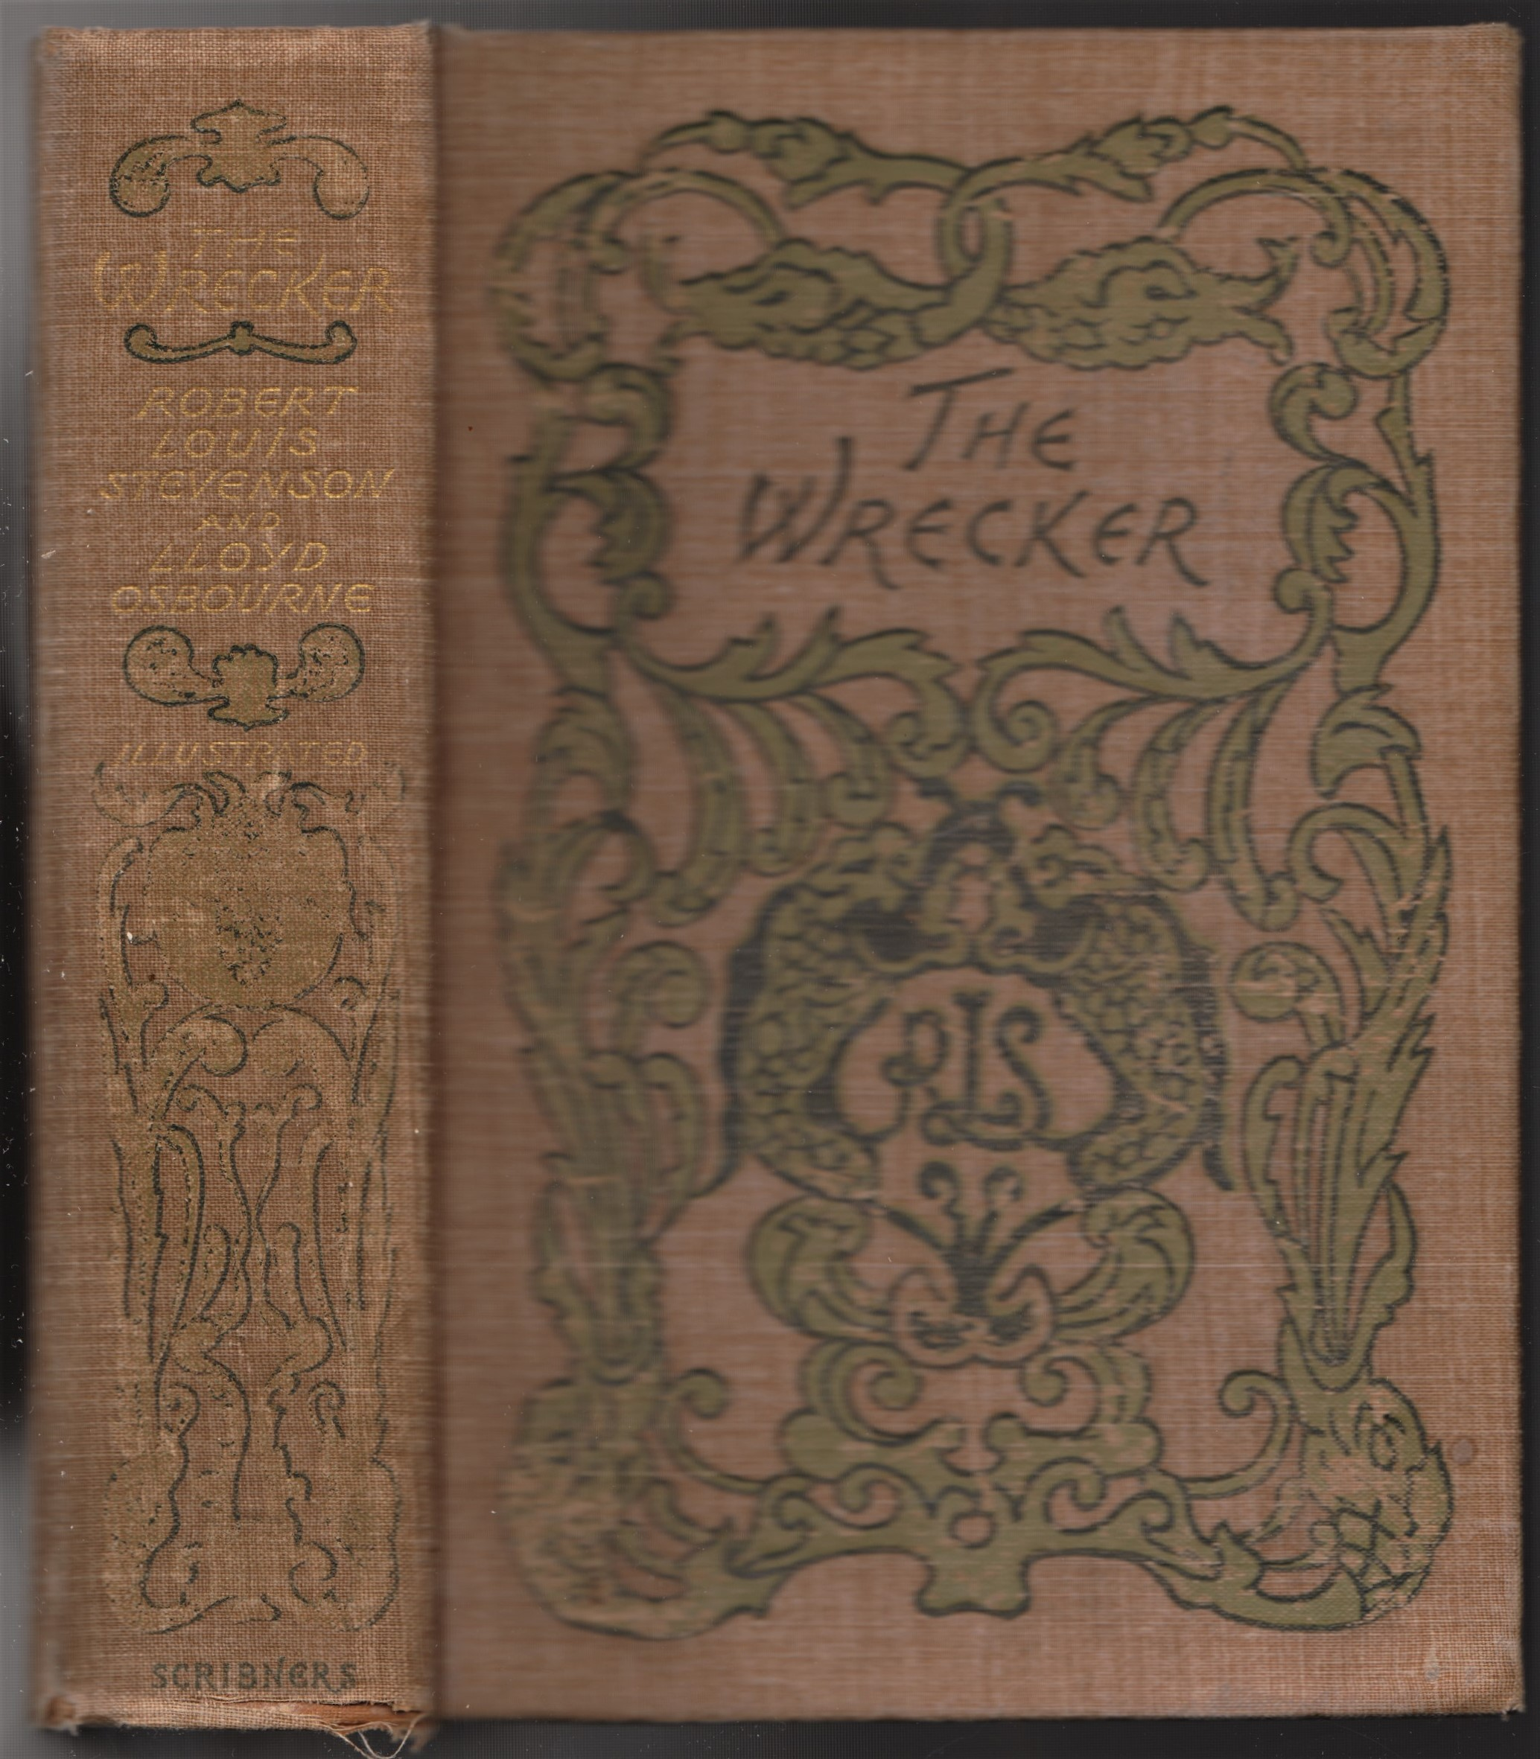

Stevenson, Robert Louis

Osbourne, Lloyd

The Wrecker
Charles Scribner's Sons, New York, 1892 first edition

Внешний вид первых изданий книги

