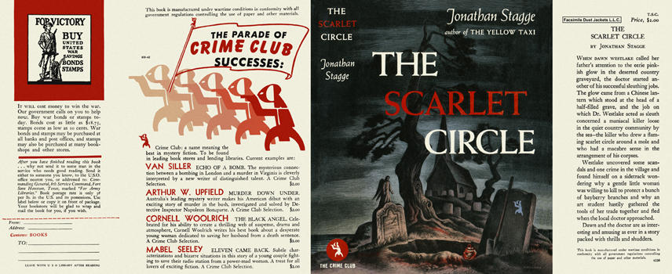

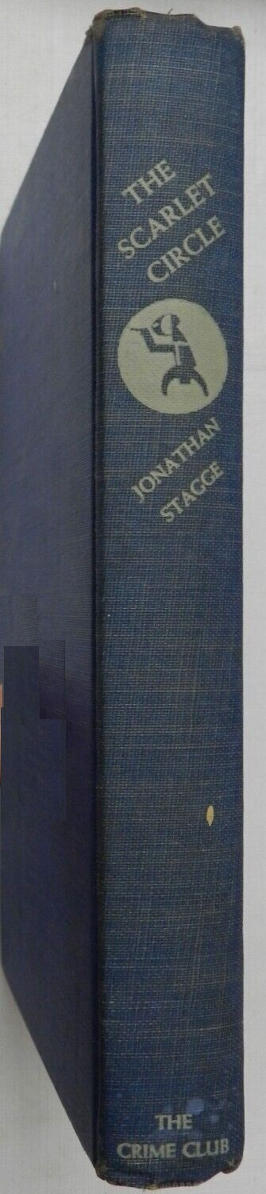

Stagge, Jonathan

The scarlet circle
Doubleday The Crime Club (USA) (1943) first printing



Stagge, Jonathan

Light from a lantern
Michael Joseph (UK) (1943) first printing

Суперобложки и внешний вид первых изданий книги

