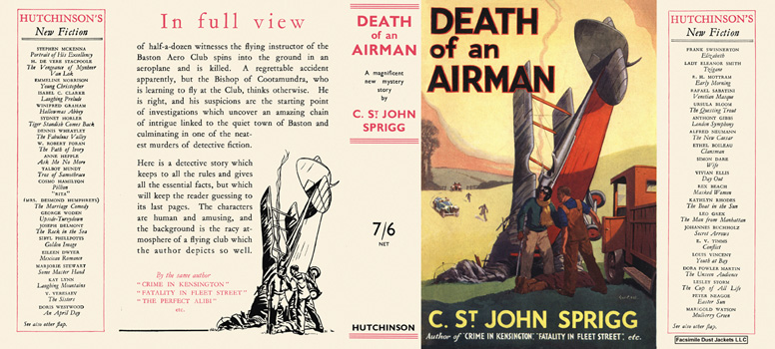

Sprigg, C. St. John

Death of an Airman
Hutchinson (UK) (1934) first printing.

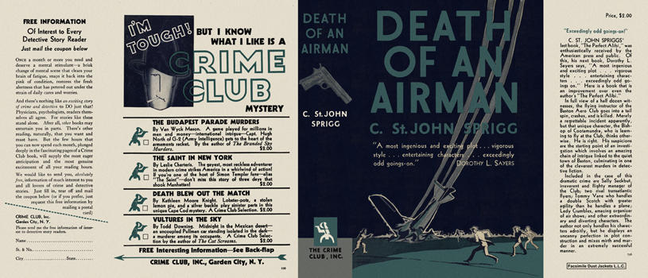

Sprigg, C. St. John

Death of an Airman
Doubleday The Crime Club (USA) (1935) first printing.

Суперобложки первых изданий книги

