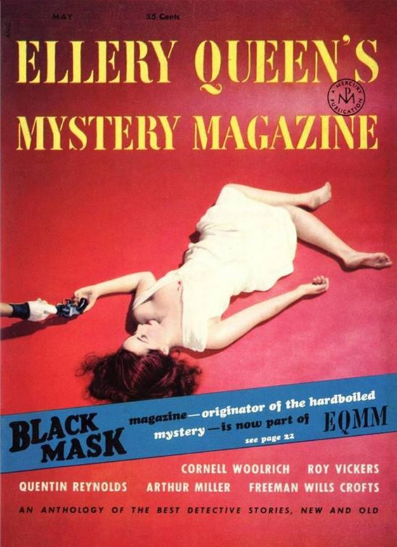



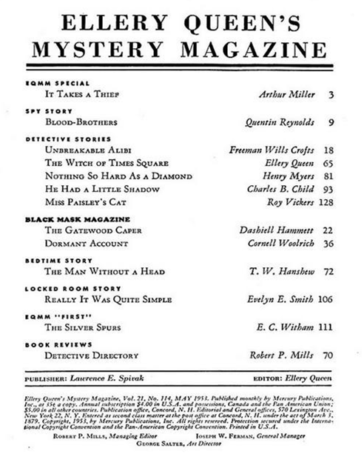

Really it was quite simple
by Evelyn E. Smith

May we make two comments by way of introducing Evelyn E. Smiths prize-winning story — one about the author and the other about her story... About Miss Smith, we would simply like to quote from her letter to your Editors: “I had been planning a longer and more orthodox story for submission to the EQMM contest, but, as the deadline grew closer and I found myself afflicted by an influx of European visitors, I realized that I would never be able to make it, so I wrote “Really It Was Quite Simple’ instead. I’ve always thought the locked-room setup was such a lot of trouble to go to just to kill someone.”... And about Miss Smith’s story, we would simply like to quote one readers reaction: “If the Editors don’t buy this story. I’ll just go out and commit suicide!”

❖
I must confess I’m utterly baffled,” young Biestleigh murmured in slack-jawed admiration as Colonel Whikehart riffled the deck of cards and, for the tenth successive time, pulled out the one previously specified. “I haven’t the foggiest notion how you do it.”
A massive gust of laughter turned Sir Odo’s equally massive body to a quivering jelly. “Hand quicker than the eye, eh, Whikehart?” he inquired.
“Just a question of knack,” the Colonel agreed with modesty. “Picked it up in India.”
“Cards are meant to be played with, not with, if you see what I mean,” said Pottridge impatiently. “How about a spot of bridge, chaps?”
The other three smiled vaguely.
“Looks fairly simple to me,” Sir Odo commented, inspecting the Colonel’s maneuvers with the cards through his eyeglass. “— Not that I mean to be disparagin’, old boy. .”
“Quite,” agreed the Colonel. “It is fairly simple.”
“I daresay,” Sir Odo continued, “it’s the sort of thing you might even manage to teach the young fella here. Make him popular with the ladies.”
Young Biestleigh flushed to the roots of his fair hair. “I’m afraid not, sir,” he protested. “About the cards, that is. I’m fearfully bad at complicated things. Why, when I read a thriller, I never understand precisely how the murderer did it, even when it’s carefully explained in pages and pages at the end.”
“Well, you’re not a readin’ man, Biestleigh.” Sir Odo explained kindly.
“Take those locked room jobs,” the youth went on, warmed by interest in his subject almost to the point of articulacy. “Never can understand how they’re done — even when it turns out the fella locked the door from inside with a bit of siring and stabbed himself with an icicle. How did he do it, actually, and why, I want to know?”
“Now you’re getting into psychology,” Sir Odo reproved. “Deep stuff; take hours to explain to you. Anyhow, those locked room affairs are utterly preposterous.” He wrung scotch out of his mustache with a practised gesture. “Wouldn’t work in reality.”
“Oh, I don’t know,” said the Colonel, absently letting the cards slide through his supple fingers. “I’ll lay you a fiver that I can shut myself up in a room with young Biestleigh here; and, at the end of ten minutes, you can come, find all the doors and windows — except the one you come in by, of course — locked, young Biestleigh dead, and no sign of me.”
“Done!” said Sir Odo promptly. He and the Colonel shook hands.
“I say there,” protested Biestleigh. “The fact is, you’re going a bit too fast there; I’m not in this thing with you chaps, you know,”
“Come now, lad” — Sir Odo clapped him on the shoulder — “surely you don’t think old Whikehart has any chance of escaping from a locked room? Think of how silly he’ll look when we break in and find him still footling about your body.”
“No,” young Biestleigh said with a firmness uncommon in him, “I really must decline. My mother — you know — she wouldn’t like it.”
“Elfreda always was such a stuffy girl,” Sir Odo pouted. “Daresay we’ll have to try it with an orphan sometime. You an orphan, Pottridge?”
“No, I am not,” replied Pottridge curtly. “And now that this damn silly nonsense is off, how about that game of bridge?”
“I have it!” Sir Odo’s globular countenance became transfigured with joy. “We don’t need to have a dead body at all! I mean to say, you could simply disappear from the locked room without killing anyone first, couldn’t you, Whikehart?”
“Much less dramatic,” the Colonel said, “but I expect I could.”
“Lot of tosh,” Pottridge commented.
“Did you say a fiver or a tenner?” Sir Odo went on anxiously.
“A tenner, if you like,” the Colonel smiled.
“Makes things more interesting,” Sir Odo said with satisfaction. “Mind you, Whikehart, when we break in there must be no sign of you at all, or you lose the bet!”
A shadow disturbed the ascetic calm of the Colonel’s face. “No need to break in; you can lock the door from the outside and unlock it after the stipulated length of time. The landlord might get a bit sticky if you damage the door.”
“Which room shall we use? Up to you, old boy,” Sir Odo proposed.
“My study,” the Colonel said. “It’s got only one door and one window — makes things simpler. Besides it opens directly off this room, so you can keep an eye on the door and the whiskey simultaneously.”
“Ten to one he has some sort of mechanical contraption there,” Sir Odo whispered to young Biestleigh, rubbing his plump palms in anticipation. “But we shall find it, never fear.”
“We!” young Biestleigh shrilled. “I hope you don’t think I’m in on this bet! Because I believe he can do it, you know. He can do anything.”
“Oh, come now,” the Colonel said, tugging his still-black mustache in evident embarrassment. “Not anything.”
“Let’s go to it, shall we?” Sir Odo suggested, too eager to spare even contempt for the craven Biestleigh. “What’s your proposal, Whikehart? Do we lock you in your study and then unlock the door after five minutes to find you have disappeared, so to speak?”
“Quite correct,” the Colonel nodded, his Mona Lisa smile widening fractionally. “But shall we make it fifteen minutes? I’m just a bit rusty, you know.”
“You’re rusty,” said Sir Odo waggishly, “or it’s rusty?” He followed the tall, thin figure of his host into a small, square room with walls distempered a dingy cream. There were several pieces of massive brown leather furniture, a few books, a number of sporting prints and guns on the walls, and innumerable tables and whatnots bearing immense quantities of brass, carved wood, ivory, and fragments of dead animals — all relics of the Colonel’s adventurous youth. A faded Oriental rug with threadbare spots passim covered the floor; the one rather narrow window — facing the door by which they’d entered — was curtained in dun monk’s-cloth. It was every inch a man’s room.
There was, as the Colonel pointed out, only the one door and one window — no other possible entrances or exits, not even a cupboard.
Sir Odo parted the curtains and looked out of window. “A straight three-story drop,” he said. “Hardly worth a tenner, eh, Whikehart?”
The Colonel smiled. “I wouldn’t jump for less than £50,” he agreed. “And even then, what with taxes the way they are, it would scarcely pay.”
“Satisfied, chaps?” Sir Odo called back to young Biestleigh and Pottridge, who hovered in the doorway, respectively apprehensive and disinterested. “Right!” He clapped the Colonel’s shoulder. “I’ll just lock this window from the inside, old boy, in case you happen to have a parachute concealed on your person.” His white mustache quivered with appreciation of his own wit. “Now we’ll nip out and lock the door. We wait for fifteen minutes; then unlock it, and you should be gone.”
“Right you are.”
“We’ll be watching the outside of the door,” Sir Odo warned, “so there’s no use trying any tricks with keys.”
“Oh, quite,” the Colonel agreed, “I wouldn’t dream of it.”
“... I don’t like this at all!” young Biestleigh blurted, as soon as the three men were alone and the door between them and the Colonel was solidly locked by Sir Odo’s loving hands. “This sort of thing gives me the creeps. If it happened in a thriller, d’you know what we’d find when we unlocked the door?”
“No,” Sir Odo replied, his eyes vainly summoning Pottridge to share the amusement. “What would we find, my boy?”
“We’d find the Colonel dead, that’s what!”
“And who would have killed him?” Sir Odo asked, restraining laughter with pretended difficulty. “Or, should I say what?”
“Well, there you’d have the puzzle, you see,” the young man said earnestly.
“Now, books are all very well, Biestleigh — I read ’em sometimes myself — but let’s get down to brass lacks. How could anyone or anything get in there to kill the Colonel?”
“Could have been poisoned first,” Pottridge suddenly contributed, staring with disfavor into his glass. “Taste of this whiskey would drown out anything.”
“Mustn’t criticize a man’s liquor, old fellow,” Sir Odo said with hauteur. “The man’s definitely an outsider,” he whispered to the unhappy Biestleigh in a voice loud enough for Pottridge to hear.
It was a long fifteen minutes. The level in the decanter had shrunk appreciably when Sir Odo pronounced it time to open the door. Even Pottridge arose from his game of Patience to peer over the baronet’s left shoulder, the space behind the right having already been pre-empted by young Biestleigh.
One could not say the study was empty — there was far too much furniture for that — but it was certainly empty of Colonel Whikehart, alive or dead.
“Amazing,” murmured Sir Odo, picking the cushion out of a wing chair and shaking it. Some stuffing emerged, but not the Colonel. “Amazing! But the explanation is probably a very simple one if we only knew it.”
“Probably,” Pottridge agreed. “Most explanations are — afterward.”
“Perhaps...” young Biestleigh began, and stopped.
“Go on, my boy,” Sir Odo encouraged him. “ ‘Out of the mouths of babes and sucklings...’ ”
“. . A priest’s hole...?” Biestleigh suggested, hopefully.
“I’m afraid architects saw little need for priests’ holes in blocks of flats built after 1930,” Sir Odo remarked, in tones that would have etched glass. “What are you doing, Pottridge?”
For that gentleman, languidly entering into the spirit of the thing, was thumping the wall. “Secret panel — hidden room,” he explained. “The boy may have something. Needn’t be for priests; might be... opium smugglers or something of the kind.”
He thumped more vigorously on the wall. A knocking from the other side responded with equal vigor.
All three jumped. “What was that?” Biestleigh quavered.
“Neighbors, I daresay,” Sir Hugh replied tartly. “You generally do have ’em on the other side of the walls in flats — a great drawback, in my opinion. However, I don’t expect they like that infernal din you’re making. How could you find a secret panel in a painted wall, man?”
“I dunno,” Pottridge replied, unabashed. “By looking, I suppose.”
“... Well,” Sir Odo concluded, his mustaches aquiver with disappointment, “I must admit that Whikehart has won his bet. And jolly clever of him too,” he added.
“Decent of you to say so, old boy,” the Colonel said, coming in from the next room.
“Whikehart!” Sir Odo exclaimed. “Good to see you, old man! Excellent trick that. However did you do it?”
“Really it was quite simple, I assure you,” the Colonel smiled. “I’ll explain it, but let’s all have a drink first.” He led the way back into the sitting room, where they all helped themselves to refreshment.
“See, I told you,” Sir Odo pointed out to young Biestleigh. “Sometimes it’s these simple jobs that are the brainiest to work out. Tell us, old fella, how did you do it?” he asked.
“Well, you see, I didn’t actually leave the room until you chaps came in. Then, when you unlocked the door, I just walked out.”
“That was jolly good—” Sir Odo stopped. “But how is it we didn’t see you?”
“Oh, that took a little more doing. I made myself invisible first, of course; trick I learned from a Yogi fella out in the Punjab — absurdly easy once you get the hang of it.”
Sir Odo laughed uproariously. “And that was all you did? And here I’ve been looking for some devilishly ingenious and complicated scheme. See—” he addressed young Biestleigh “I told you it would turn out to be something childishly simple, didn’t I? Why is your mouth hanging open like that, boy? Damned unprepossessing.”
“Why I–I never could figure out these locked-room things, I expect—” the young man faltered uneasily. “You chaps are just too brainy.”
“Bridge is excellent for sharpening the wits, “Pottridge suggested. “How about a game?”
“Well, why not,” the Colonel said affably. “I can afford it tonight.”
“Write you a check,” Sir Odo said quickly. “Only, you won’t cash it for a day or two yet, will you, old chap? Fact is... few matters with my bank... straightening out.”
“Of course, of course,” the Colonel replied, handing him a pen. “I quite understand.”
“I don’t,” said young Biestleigh.

