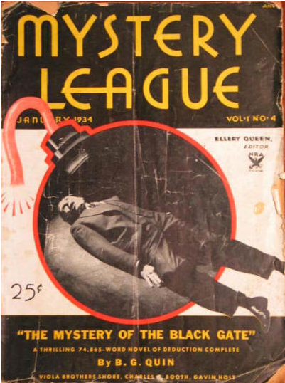

Mystery League, v1 #4, January 1934
ifc. · Through the Looking Glass · Ellery Queen · ed
  - 2 · The Mystery of the Black Gate · B. G. Quin · na; illustrated by Eugene Thurston
  - 76 · The Mackenzie Case · Viola Brothers Shore · ss; illustrated by Eugene Thurston
  - 86 · Puzzle Department · [uncredited] · pz
  - 89 · To the Queen’s Taste · Ellery Queen, uncredited · cl; unsigned, but written in the first person by “Queen”.
  - _89 · Sherlockismus · Ellery Queen · br; reviewing The Private Life of Sherlock Holmes by Vincent Starrett (1933).
  - 96 · Orchid Lady · Charles G. Booth · ss; illustrated by Eugene Thurston
  - 104 · Drums Beat at Night [Part 3 of 3] · Gavin Holt · sl; illustrated by Eugene Thurston

Обложка журнала, в котором впервые был напечатан рассказ

