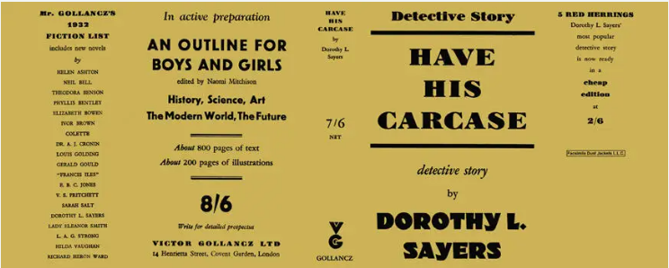

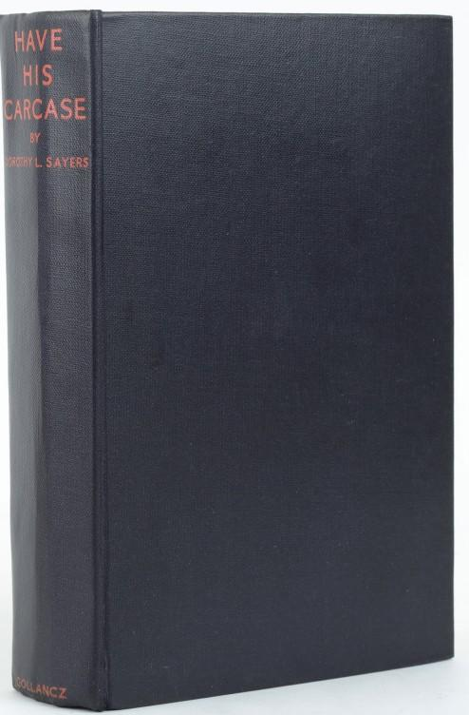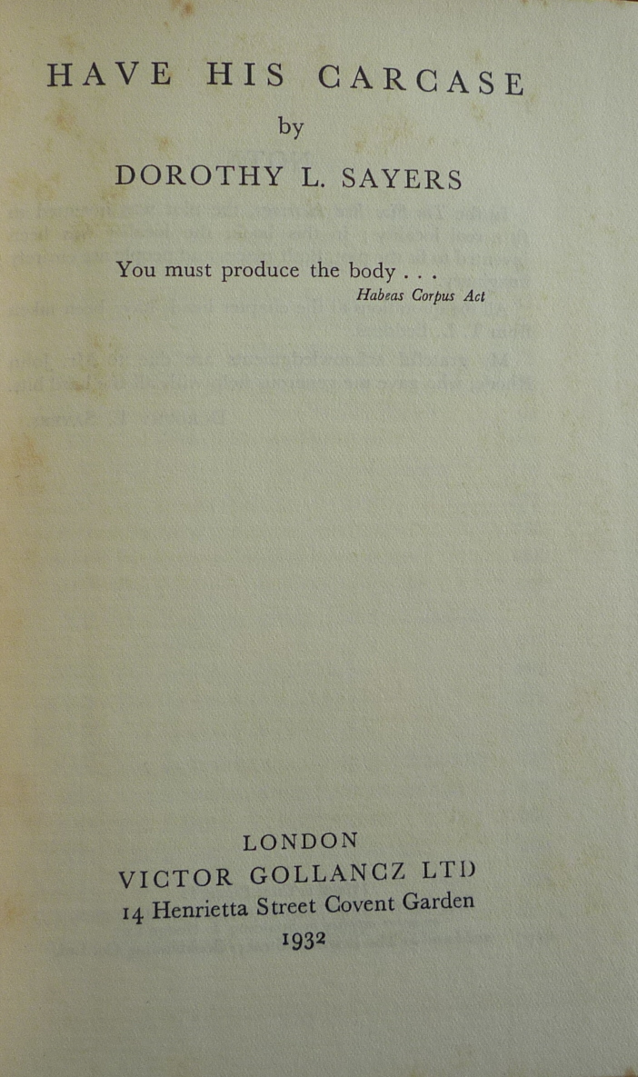

Sayers, Dorothy L.
Have his carcase
V. G. Gollancz (UK) (1932) first printing

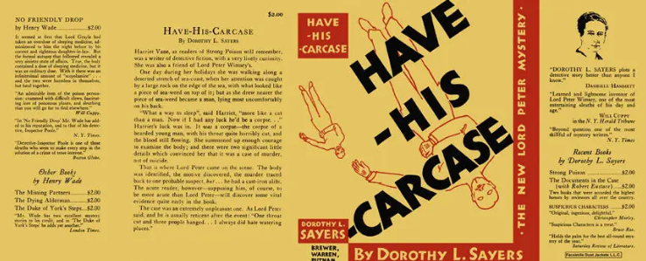

Sayers, Dorothy L.
Have his carcase
Brewer, Warren and Putnam (USA) (1932) first printing

Суперобложки и внешний вид первых изданий романа

