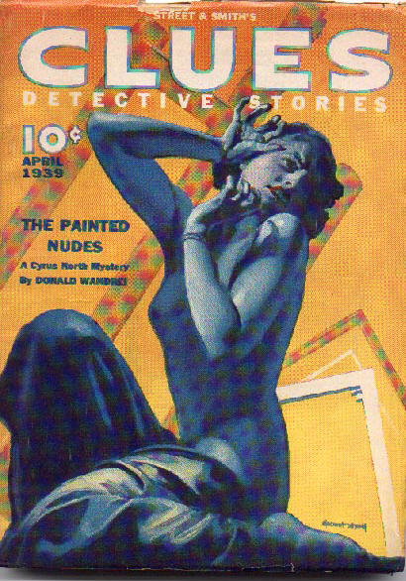

Clues Detective Stories [Vol. XLI No. 5, April 1939]
ed. Anthony Rud

  - 6 · The Story Trail · [The Editor] · cl
  - 6 · [letter] · J. J. des Ormeaux · lt
  - 9 · The Painted Nudes [Cyrus North] · Donald Wandrei · nv; illustrated by Kirchner
  - 34 · Just Sentenced, Two Robbers Wed · [uncredited] · ms
  - 35 · Murder Is a Pipe · Otis Adelbert Kline · ss
  - 40 · Circus Outcast · Harry Lee Fellinge · ss
  - 54 · The Law and the Lawless · [The Editor] · cl
  - 55 · The Poisoned Bowl · J. J. des Ormeaux · nv; illustrated by Kirchner
  - 84 · Gypped by Gypsies · [uncredited] · ms
  - 85 · The Man Who Wanted to Die · Robert C. Blackmon · ss
  - 95 · The Drums Drone Death · J. Allan Dunn · nv
  - 130 · No More C. D. Specials · [The Editor] · ed

Обложка журнала, в котором впервые был напечатан рассказ

