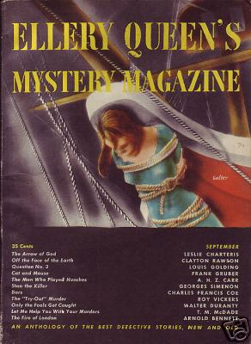

Ellery Queen’s Mystery Magazine [v14, #70, September 1949] ed. Ellery Queen (American Mercury, 35¢, 144pp+, digest)
  - fc. · [photo] · Anon. · cv
  - 3 · The Arrow of God [Simon Templar (The Saint)] · Leslie Charteris · nv
  - 23 · Question No. 3 · Louis Golding · ss Argosy Aug 6 1938
  - 26 · Off the Face of the Earth [The Great Merlini] · Clayton Rawson · nv
  - 46 · Bars · Charles Francis Coe · ss The Smart Set 1929
  - 63 · Guess Who?: Basil Willing · Talbot C. Hatch · qz
  - 65 · The “Try-Out” Murder [Department of Dead Ends] · Roy Vickers · ss Fiction Parade and Golden Book Magazine May 1936, as “The Fish Pond”
  - 74 · Let Me Help You with Your Murders · T. M. McDade · ss
  - 81 · Only the Fools Get Caught · Walter Duranty · ss Esquire Oct 1936
  - 86 · Cat and Mouse · Frank Gruber · ss Black Mask Aug 1938, as “The Ring and the Finger”
  - 97 · Stan the Killer [Insp. Jules Maigret] · Georges Simenon; translated by Anthony Boucher · nv; translated from the French (“Stan Le Tueur”, Police-Roman, December 23, 1938).
  - 118 · Leaves from the Editors’ Notebook: Queen’s Quorum: Part Four · Ellery Queen · ar Twentieth Century Detective Stories, ed. Ellery Queen, World 1948; revised.
  - 124 · The Fire of London [Cecil Thorold] · Arnold Bennett · ss The Windsor Magazine Jun 1904
  - 135 · The Man Who Played Hunches · A. H. Z. Carr · ss Harper’s Magazine Nov 1935, as “The Hunch”

Обложка журнала, в котором был напечатан рассказ

