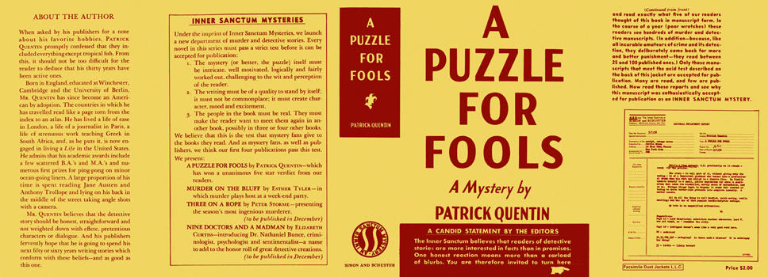

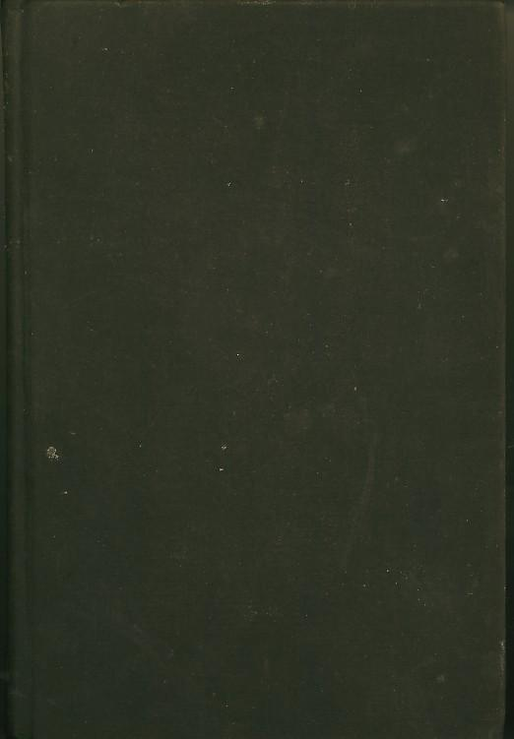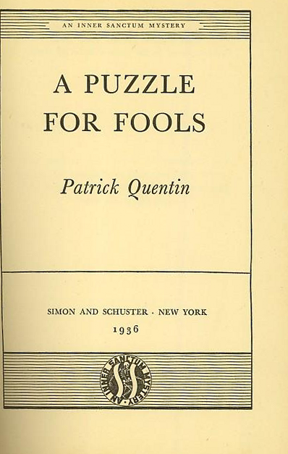

Quentin, Patrick
A puzzle for fools
Simon and Schuster (USA) (1936) first printing.

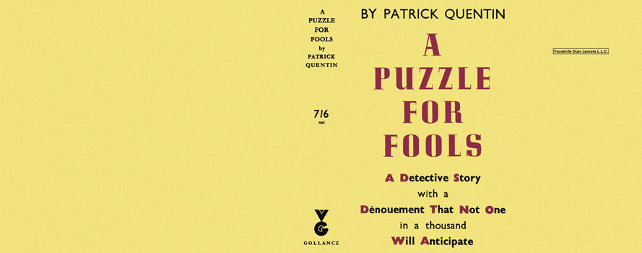

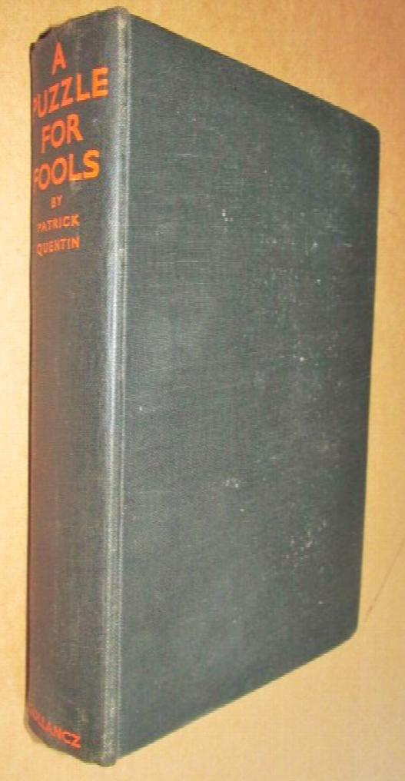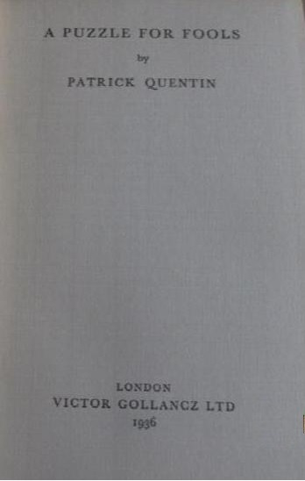

Quentin, Patrick
A puzzle for fools
V. G. Gollancz (UK) (1936) first printing.

Суперобложки и внешний вид первых изданий книги

