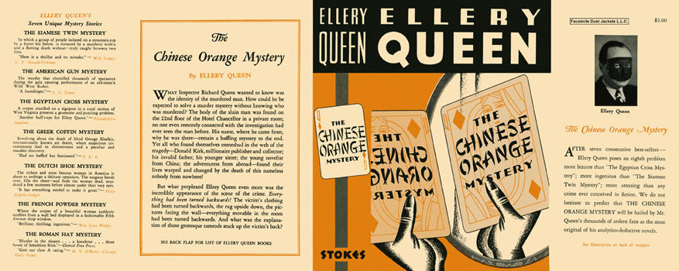

Queen, Ellery
The Chinese orange mystery
Frederick A. Stokes Company (USA) (1934) first printing

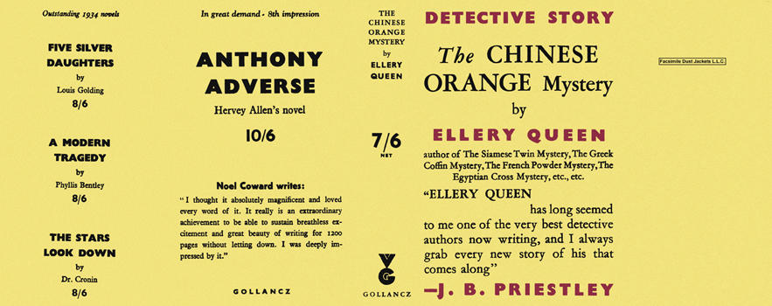

Queen, Ellery
The Chinese orange mystery
V. G. Gollancz (UK) (1934) first printing

Суперобложки первых изданий романа

