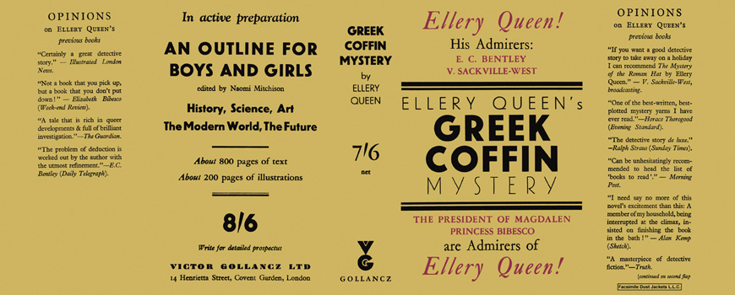

Queen, Ellery
The Greek coffin mystery
V. G. Gollancz (UK) (1932) first printing

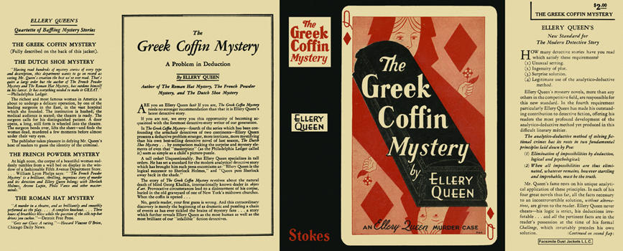

Queen, Ellery
The Greek coffin mystery
Frederick A. Stokes Company (USA) (1932) first printing

Суперобложки первых изданий романа

