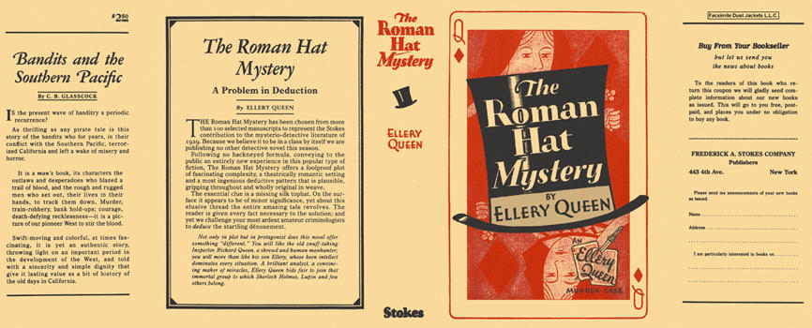

Queen, Ellery
The roman hat mystery
Frederick A. Stokes Company (USA), 1929
first printing

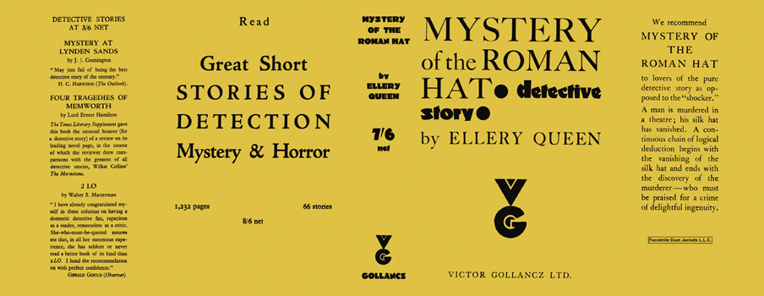

Queen, Ellery
Mystery of the roman hat
V. G. Gollancz (UK), 1929
first printing

Суперобложки первых изданий книги

