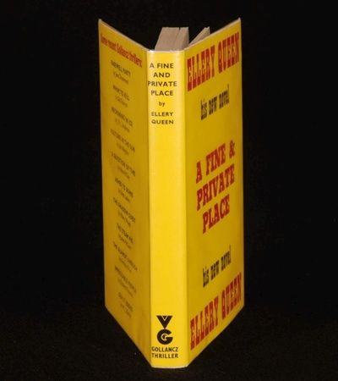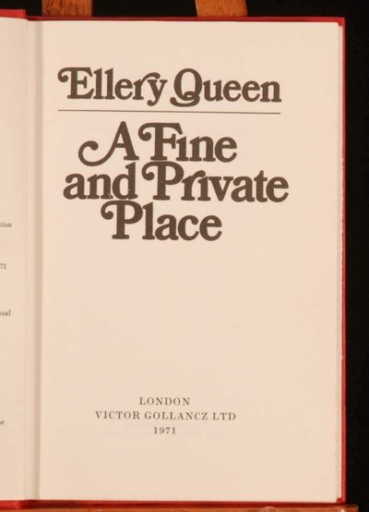

A nice UK First Edition

Queen E. A fine and private place. London: Gollancz, 1971

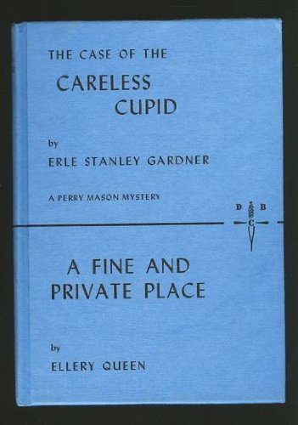

Издание Detective Book Club.
New York: Walter J. Black, 1971

