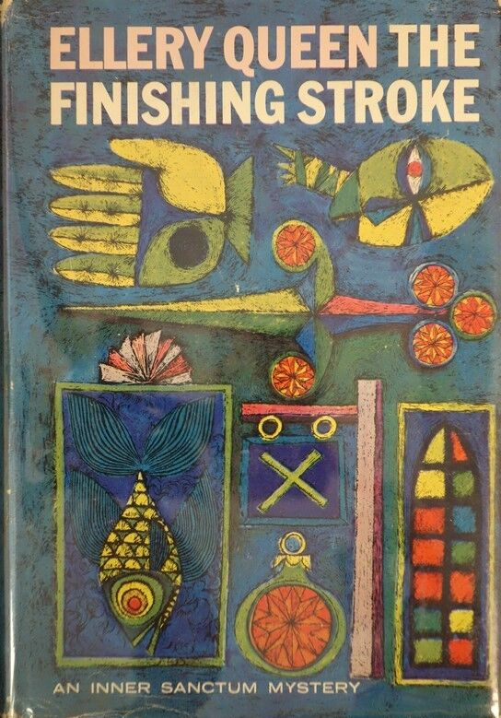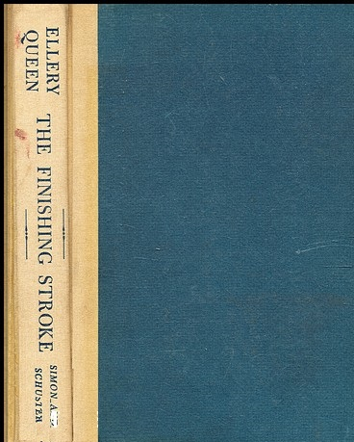

Queen, Ellery

The finishing stroke
Simon and Schuster (USA) (1958) first printing

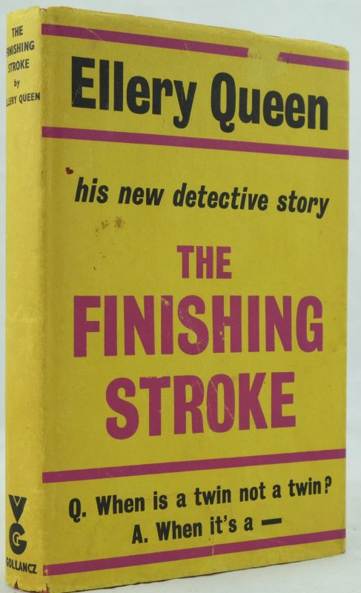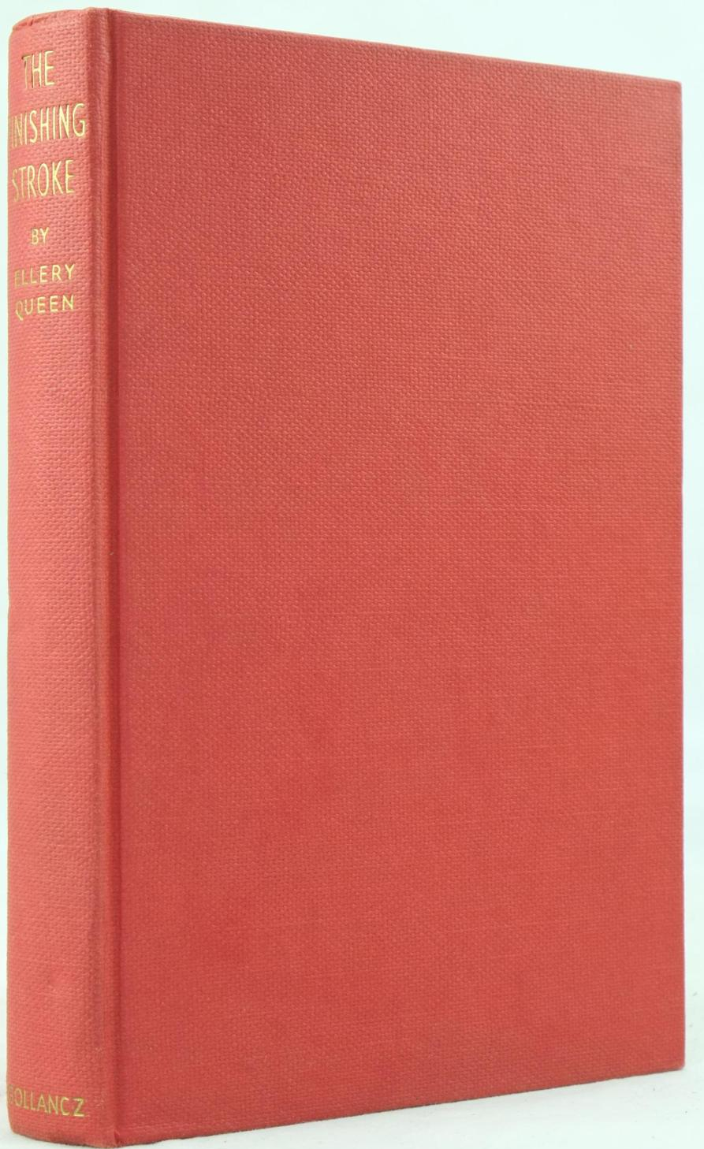

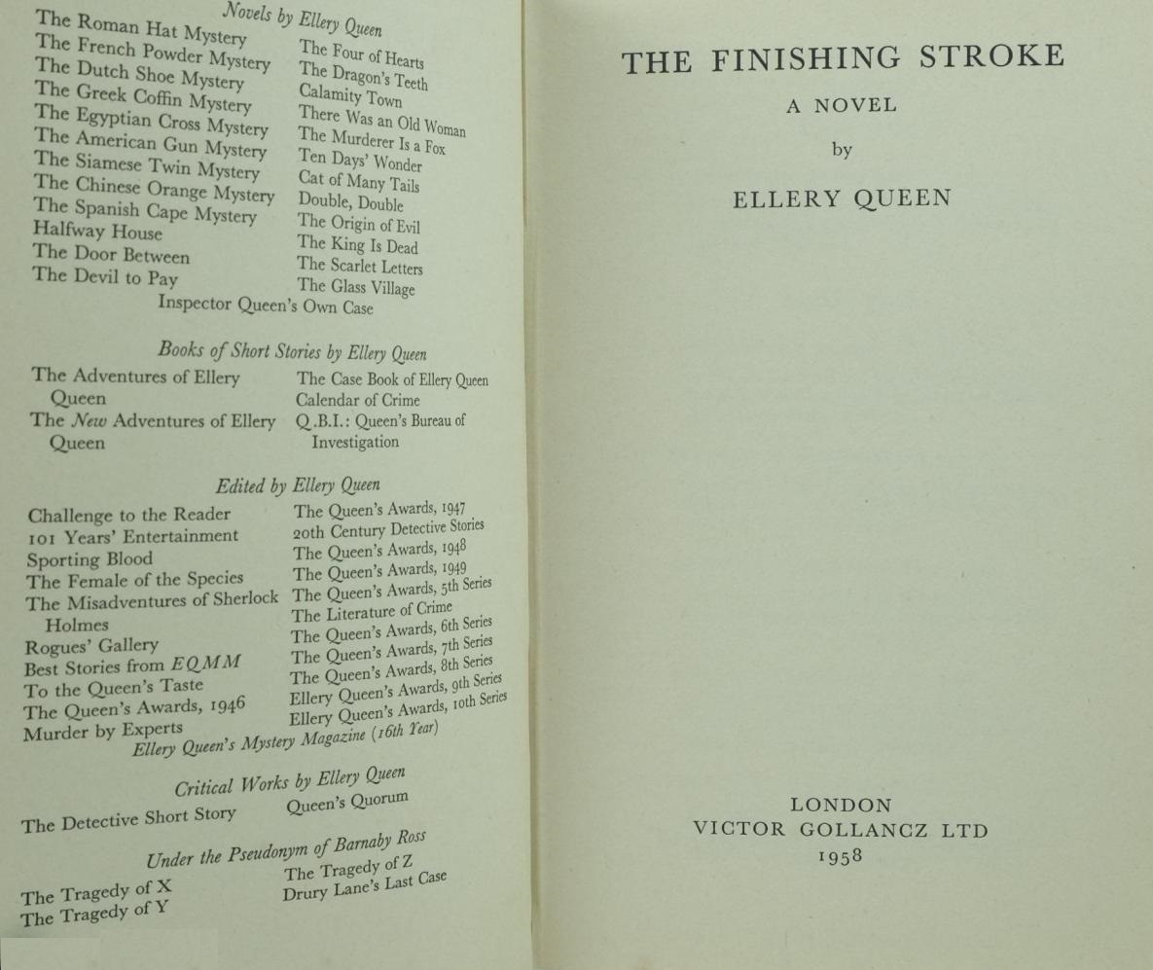

Queen, Ellery

The finishing stroke
Victor Gollancz (UK) (1958) first printing

Суперобложки и внешний вид первых изданий романа

