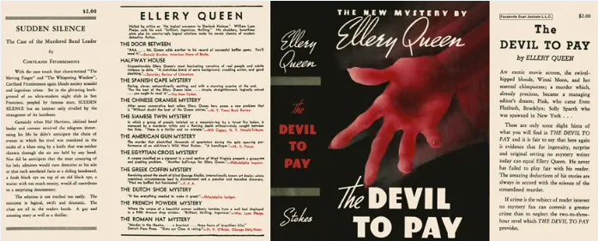

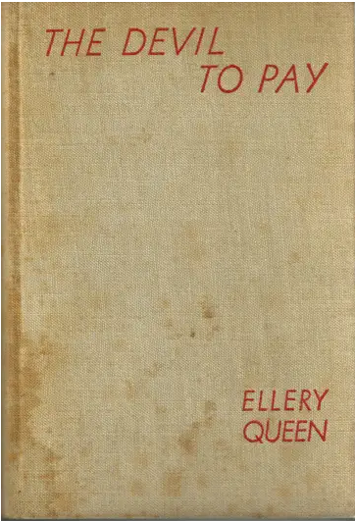

Queen, Ellery
The devil to pay
Frederick A. Stokes Company (USA) (1938) first printing.

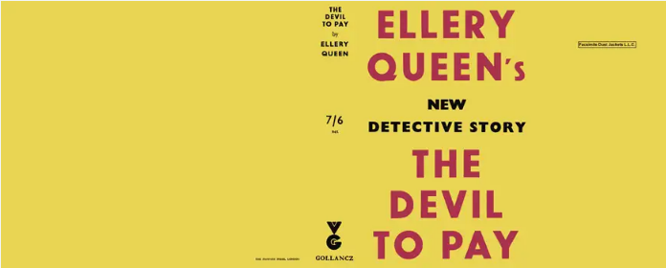

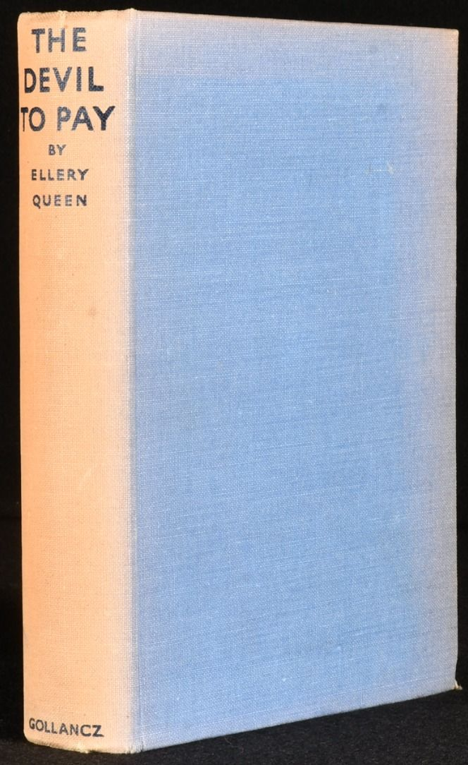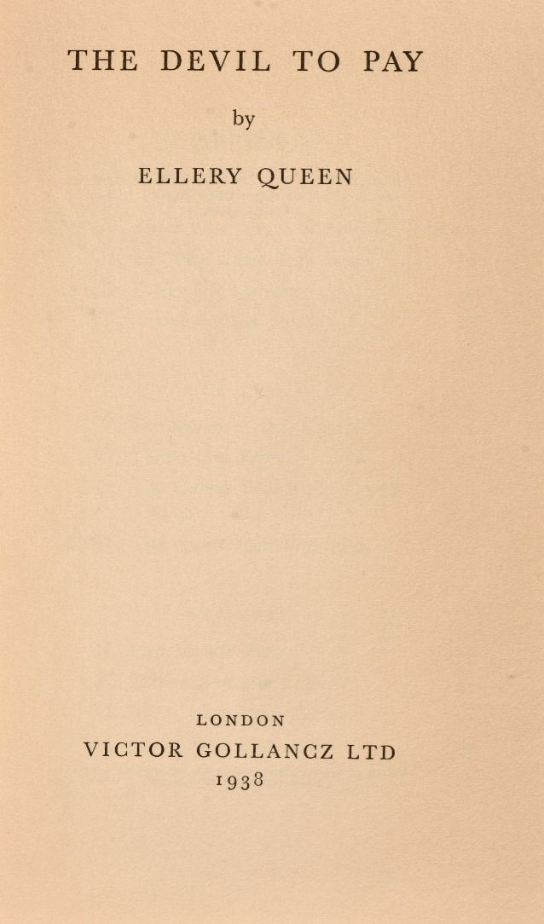

Queen, Ellery
The devil to pay
V. G. Gollancz (UK) (1938) first printing

Суперобложки и внешний вид первых изданий романа

