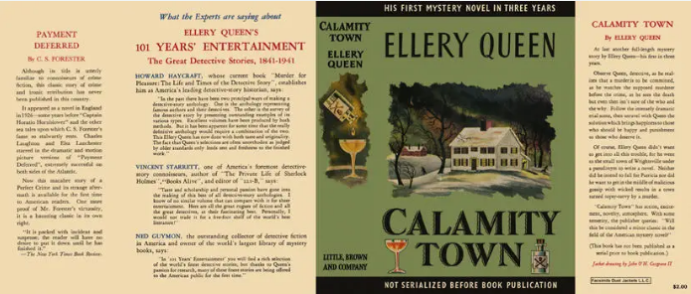

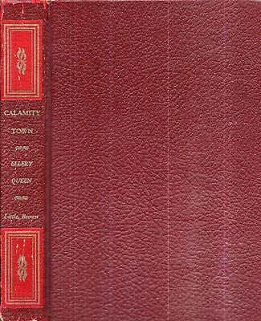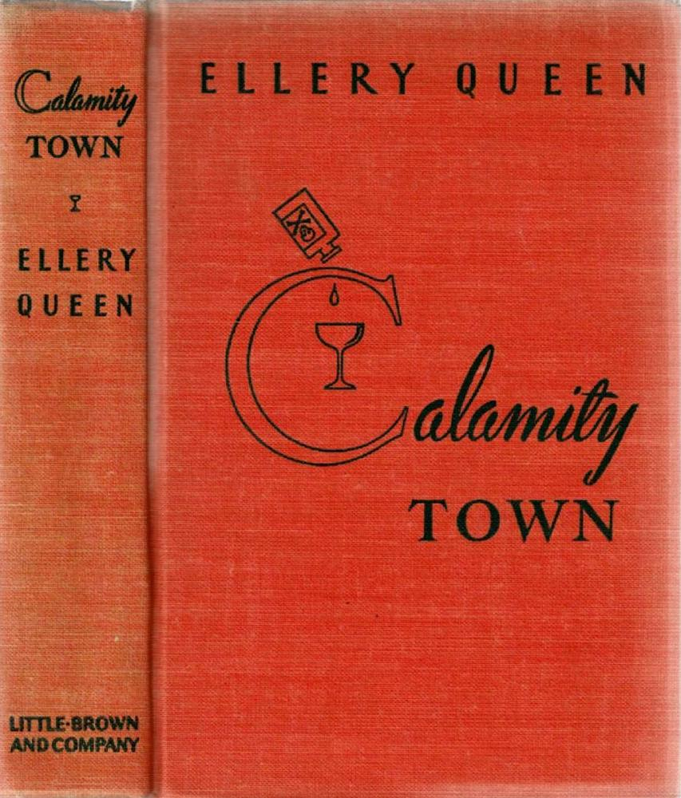

Queen, Ellery
Calamity town
Little, Brown and Company (USA) (1942) first printing

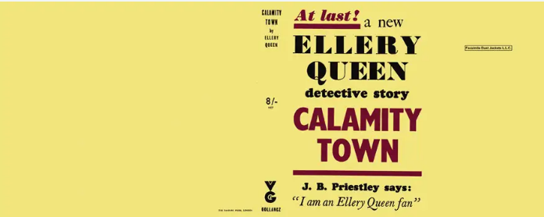

Queen, Ellery
Calamity town
V. G. Gollancz (UK) (1942) first printing

Суперобложки и внешний вид первых изданий романа

