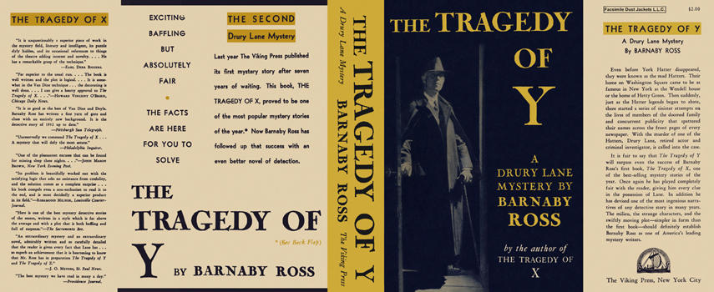

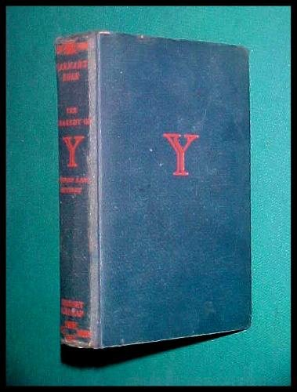

Ross B. The tragedy of Y. New York: Viking press, 1932

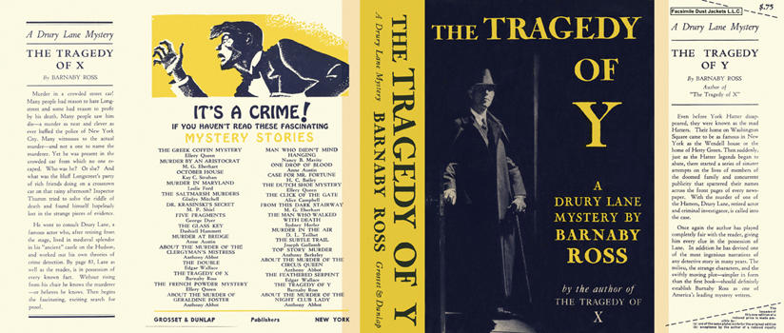

Ross B. The tragedy of Y. New York: Grosset and Dunlap, 1932

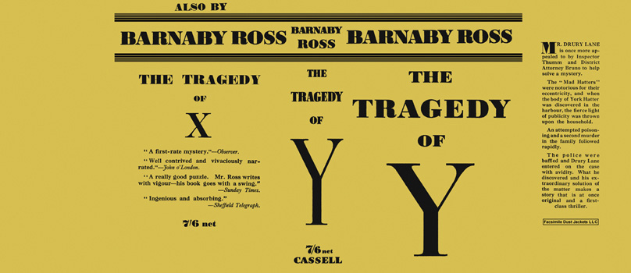

Ross B. The tragedy of Y. London: Cassell, 1932

