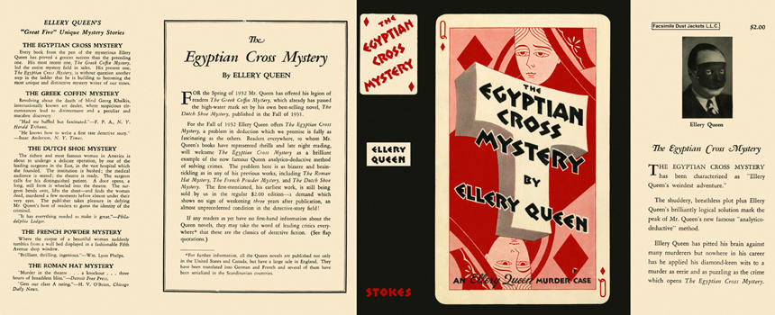

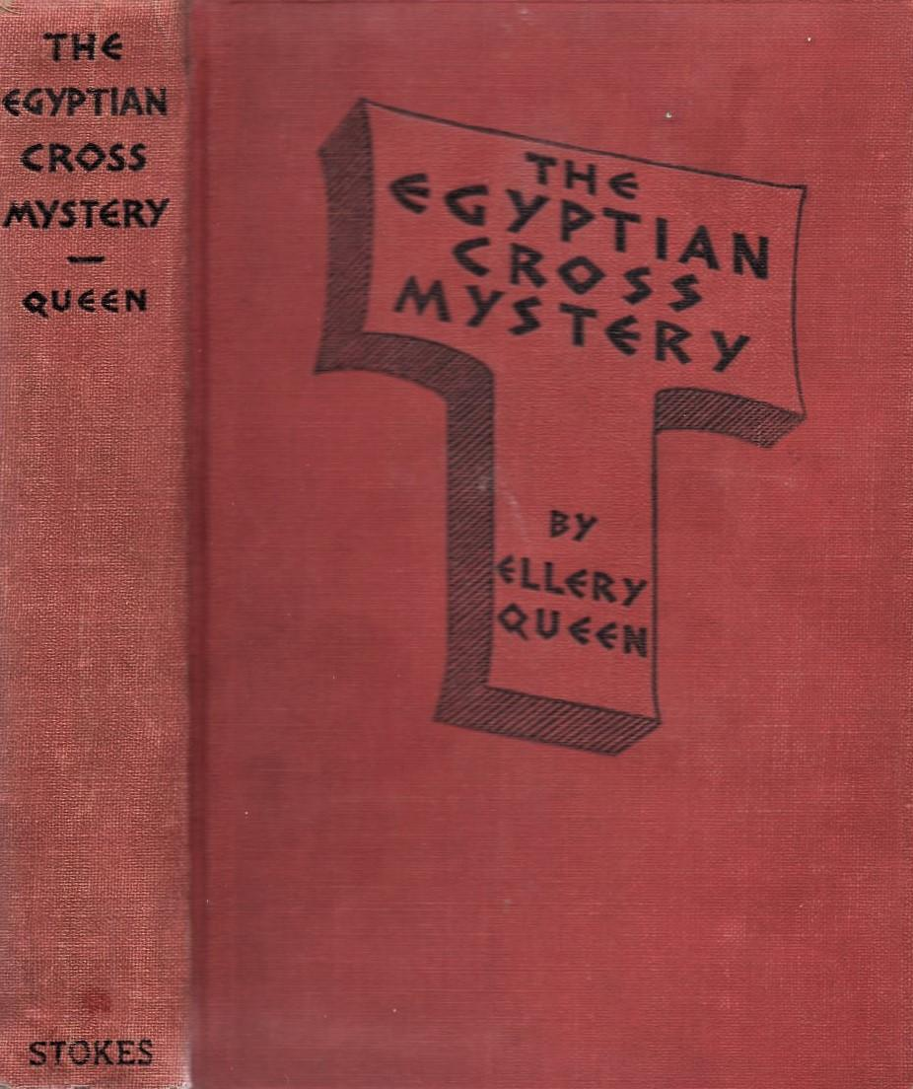

Queen, Ellery

The Egyptian cross mystery
Frederick A. Stokes Company (USA) (1932) first printing

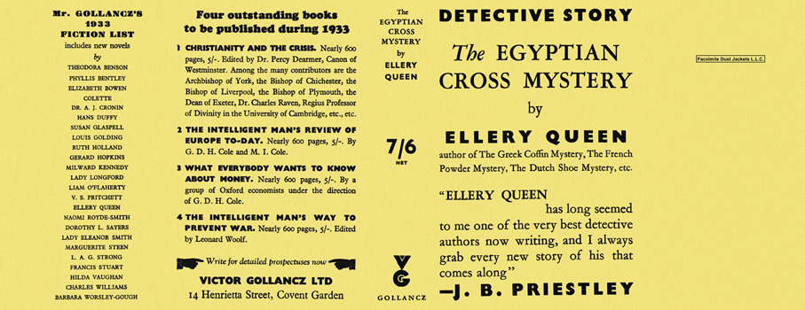

Queen, Ellery

The Egyptian cross mystery
V. G. Gollancz (UK) (1932) first printing

Суперобложки и внешний вид первых изданий книги

