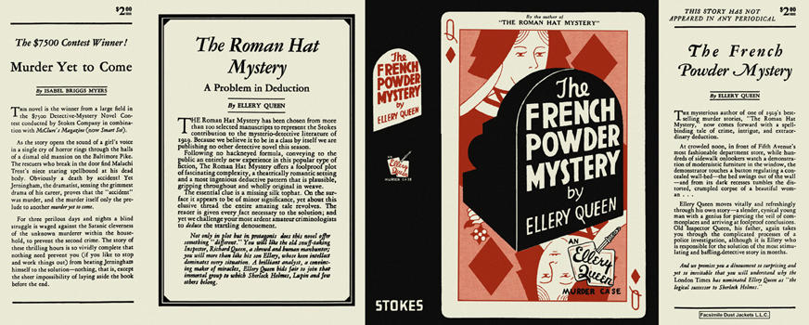

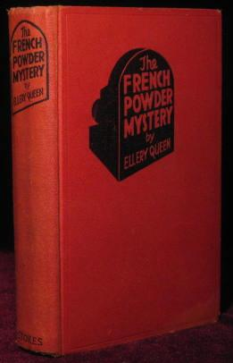

Queen, Ellery

The french powder mystery
Frederick A. Stokes Company (USA) (1930) first printing

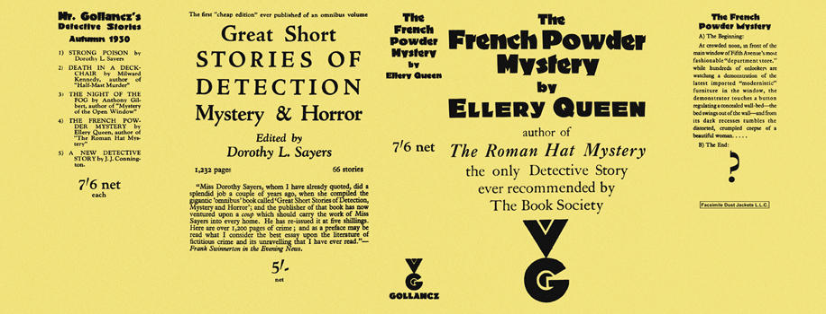

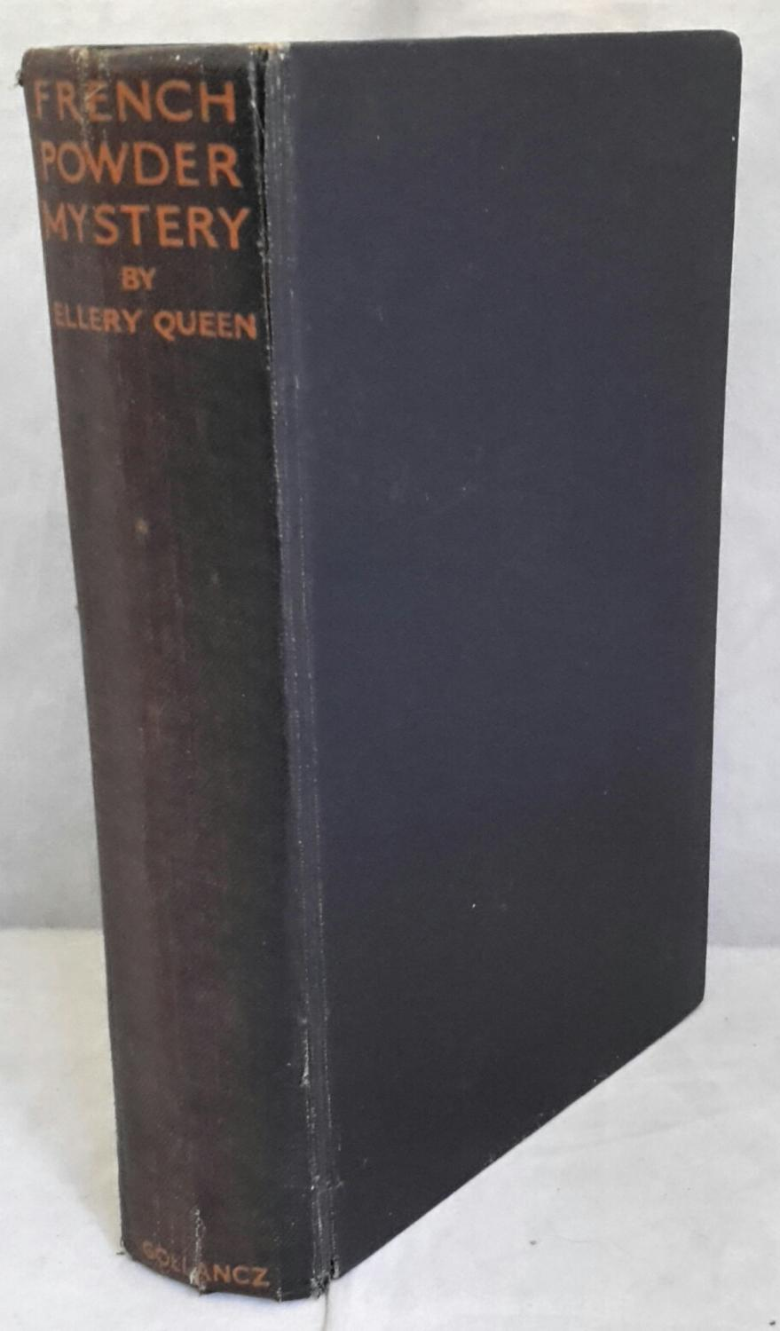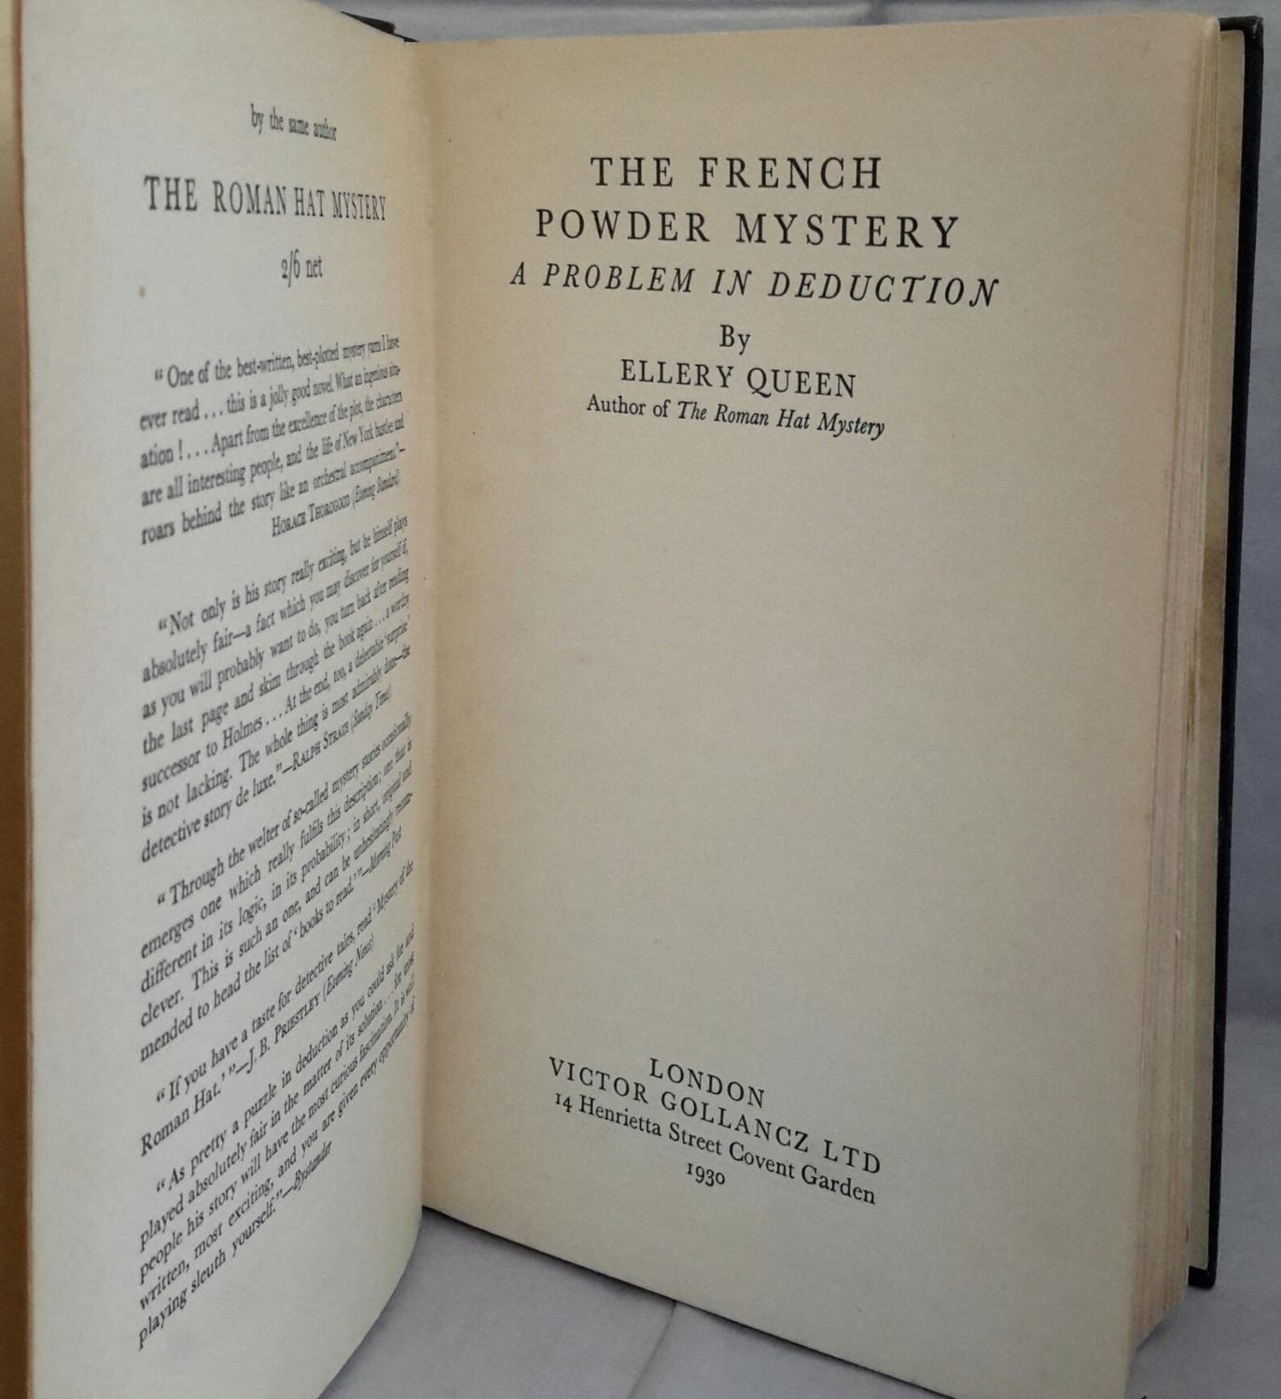

Queen, Ellery

The french powder mystery
V. G. Gollancz (UK) (1930) first printing

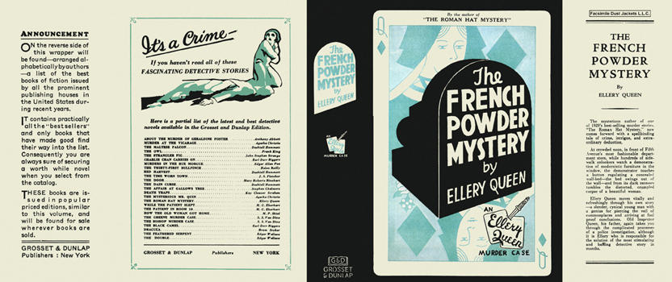

Queen, Ellery

The french powder mystery
Grosset & Dunlap (USA) (1930)

Суперобложки и внешний вид первых изданий книги

