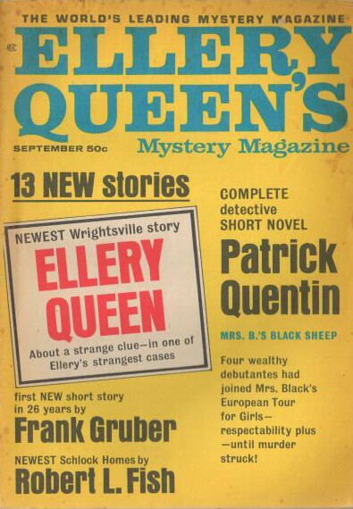

Ellery Queen’s Mystery Magazine, v 50, N 3 (September 1967)

  - 6 · Wedding Anniversary [Ellery Queen] · Ellery Queen
  - 16 · Hardcovers and Paperbacks of the Month · [Various]
  - 17 · Eagle in His Mouth · Frank Gruber
  - 29 · Mrs. B.’s Black Sheep · Patrick Quentin
  - 55 · The Greatest Snatch in History · Steve April
  - 59 · The Adventure of the Missing Three-Quarters [Schlock Homes] · Robert L. Fish
  - 67 · Murder of a Priest · Arthur Porges
  - 73 · The Death Wish · Larry Maddock
  - 80 · The Seventy-Sixth Face [Dr. Jason Love] · James Leasor
  - 88 · The Washing Machine · Rev. Norman E. Douglas
  - 92 · They Said It Couldn’t Be Done · John Pick
  - 113 · Best Mysteries of the Month · Anthony Boucher
  - 115 · Alias Mr. Manchester · Youngman Carter · ss
  - 123 · A Tale from the Chaucer · Susan Sears
  - 135 · The Shadow of His Absence · Frank Sisk
  - 144 · Traffic Violation · William Bankier
  - 153 · In the Fiction Alcove · Nedra Tyre

Обложка журнала, в котором был впервые напечатан рассказ

