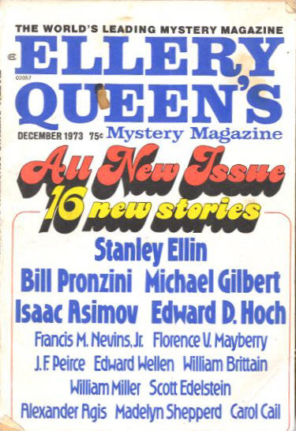

Ellery Queen’s Mystery Magazine
v62 #6, Whole No. 361, December 1973
ed. Ellery Queen (Davis Publications, Inc., 75¢, 162pp, digest)
  - 6 · The Corruption of Officer Avakadian · Stanley Ellin · ss
  - 15 · Green Ink · William Miller · vi
  - 17 · The Death of Mrs. Key [Patrick Petrella] · Michael Gilbert · ss Reveille December 2 1972
  - 26 · The Prisoner · Edward Wellen · ss
  - 30 · Mr. Strang Discovers a Bug [Leonard Strang] · William Brittain · ss
  - 43 · What Does It Feel Like? · Scott Edelstein · ss
  - 50 · The Double Death of Nell Quigley [William Shakespeare, Detective] · J. F. Peirce · ss
  - 64 · The Blue Room · Alexander Agis · ss; in EQMM’s “Department of First Stories”.
  - 73 · Mrs. Lamb’s Nose Dreams · Carol Cail · ss; in EQMM’s “Department of First Stories”.
  - 78 · Garden of Evil · Carol Cail · ss
  - 87 · The Jury Box · John Dickson Carr · rc
  - 89 · Six Thousand Little Bonapartes [Loren Mensing] · Francis M. Nevins, Jr. · ss
  - 102 · The Lucky Stone · Madelyn Shepperd · ss
  - 107 · In the Secret Hollow · Florence V. Mayberry · ss
  - 119 · The Six Suspects [Black Widowers] · Isaac Asimov · ss
  - 135 · The Invisible Guest · D. R. Bensen · pm
  - 136 · The Gold Buddha Caper [Ulysses S. Bird] · Edward D. Hoch · ss
  - 150 · Proof of Guilt · Bill Pronzini · ss
  - 160 · Index to Volume 62 · [uncredited] · ix

Обложка журнала, в котором впервые был напечатан рассказ

