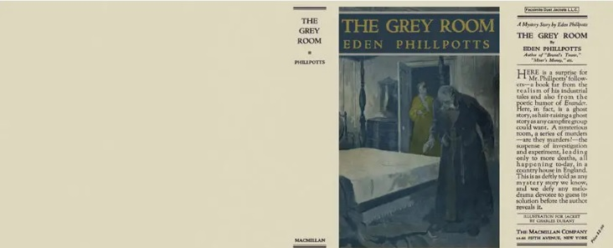

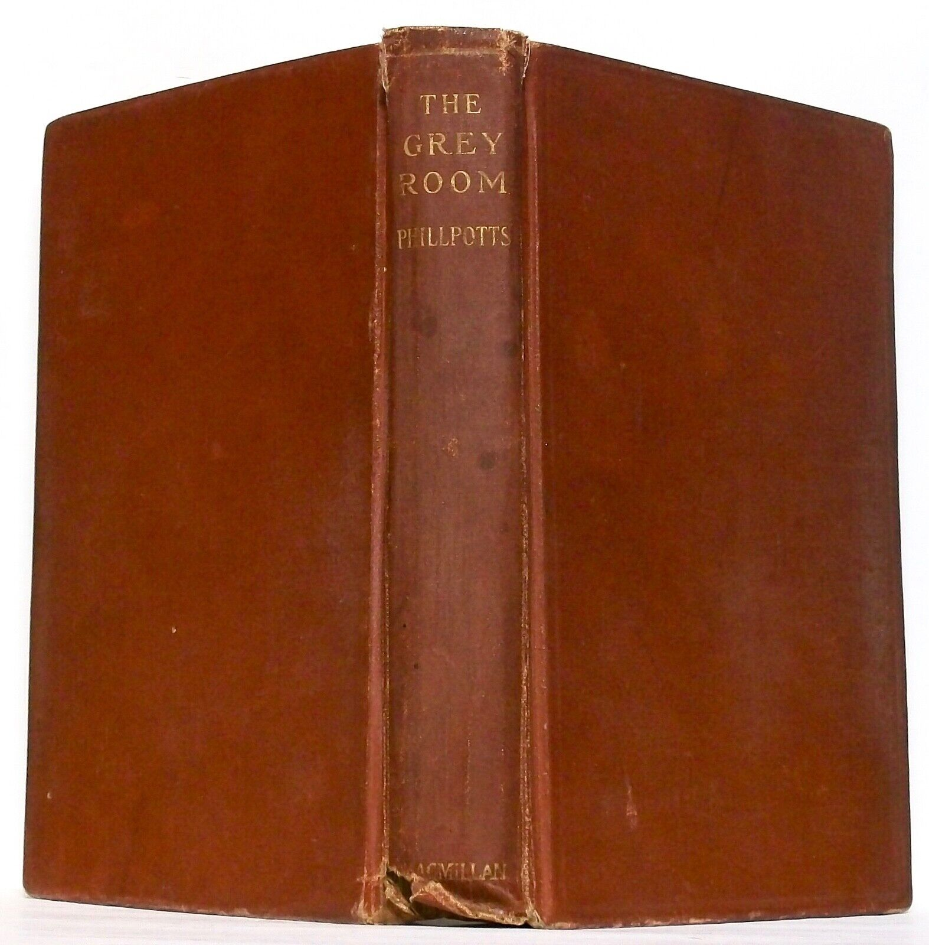

Phillpotts, Eden
The grey room
The Macmillan Company (USA) (1921) first printing.

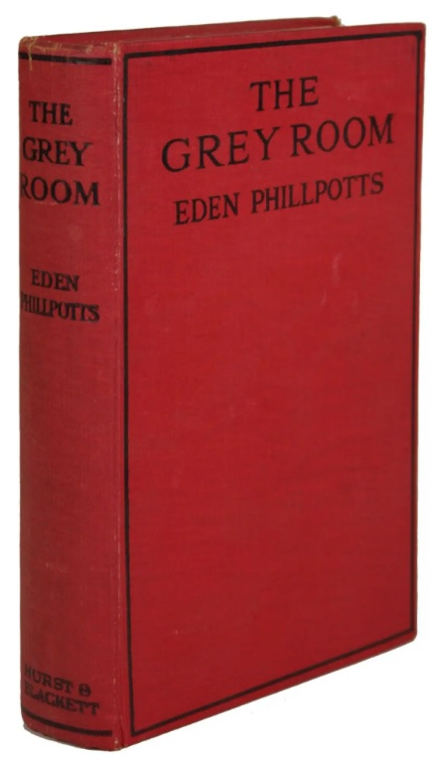

Phillpotts, Eden
The grey room
Hurst and Blackett, Ltd. (UK) (1922) first printing

Суперобложка и внешний вид первых изданий романа

