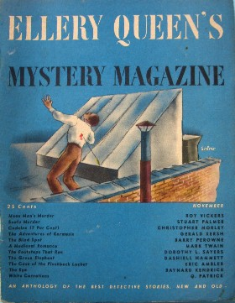
Ellery Queen's Mystery Magazine, November 1945
Detective Stories
• Mean Man's Murder by Roy Vickers , pp. 4-26
• Snafu Murder by Stuart Palmer, pp. 27-41
• The Footsteps That Ran by Dorothy L. Sayers, pp. 75-87
• Case of the Pinchbeck Locket by Eric Ambler, pp. 97-101
• The Eye by Baynard Kendrick, pp. 102-114
• White Carnations by Q. Patrick, pp. 115-127
Secret Service Story
• Codeine (7 Per Cent) by Christopher Morley, pp. 42-46
Riddle Stories
• The Blind Spot by Barry Perowne, pp. 57-68
• A Medieval Romance by Mark Twain, pp. 69-74
The Adventures of Karmesin
• Karmesin, Murderer by Gerald Kersh, pp. 47-52
• Karmesin, Jewel Thief by Gerald Kersh, pp. 53-56
• The Green Elephant by Dashiell Hammett, pp. 88-96

Обложка журнала, в котором был напечатан рассказ Барри Пероуна

