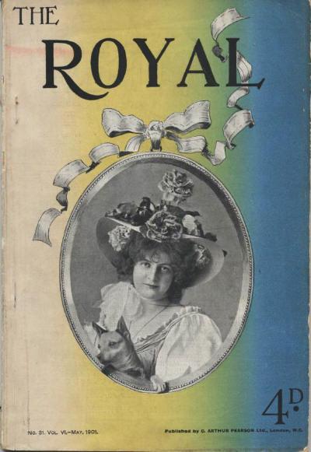

The Royal Magazine, v 6, N 31, May 1901

  - 3 · From the Stalls · [uncredited] · pi
  - 10 · The Fenchurch St. Mystery [Old Man in the Corner] · Baroness E. Orczy · ss; illustrated by P. B. Hickling
  - 19 · King Edward as a Sportsman · R. Maingay · ar
  - 25 · An I.O.U. · Owen Oliver · ss; illustrated by Victor Prout
  - 30 · The Art of the Camera · [uncredited] · cl
  - 37 · The Purple Cloud [Part 5 of 6] · M. P. Shiel · sl; illustrated by J. J. Cameron
  - 46 · “If” · Frank Foulsham & A. C. Banfield · ar
  - 51 · “Hats Off!” · Hector Grainger · ar
  - 54 · The Perfect Copy · E. C. Heath Hosken · ss; illustrated by Clement Flower
  - 60 · Flying Beasts and Flightless Birds · Gambier Bolton, F.Z.S. · ar
  - 65 · The Passing of a Shadow · Mary Manifold · ss; illustrated by F. Anger
  - 68 · A Book with a History · [uncredited] · ar
  - 69 · How the Navy Is Run: Paying Off a Warship · Archibald S. Hurd · ar
  - 74 · A Singular Duel · M. McD. Bodkin · ss; illustrated by R. Osborne
  - 81 · Table Golf · Stanley White · ar
  - 84 · A Dead Love · Philip Hemery · pm
  - 85 · The Vicar’s Legacy · Victor L. Whitechurch · ss; illustrated by P. Bell
  - 92 · Risms and Rhythms · [uncredited] · ms

Обложка журнала, в котором впервые был напечатан рассказ

