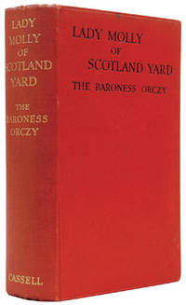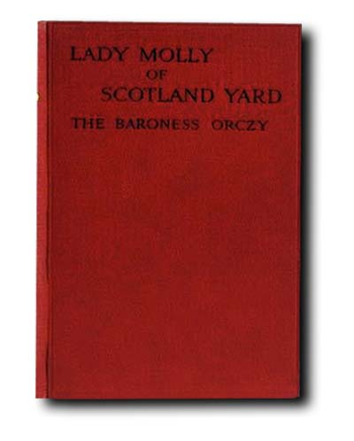

The Baroness Orczy

Lady Molly of Scotland Yard
London: Cassel and Company, 1910
First edition

