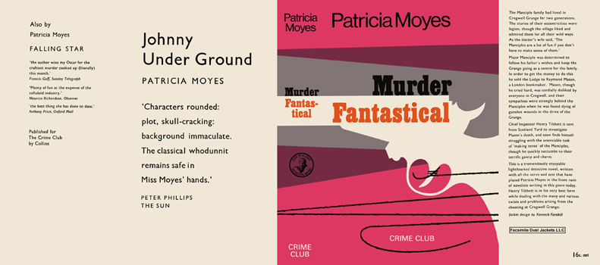

Moyes, Patricia
Murder fantastical
Collins The Crime Club (UK) (1967) first printing.

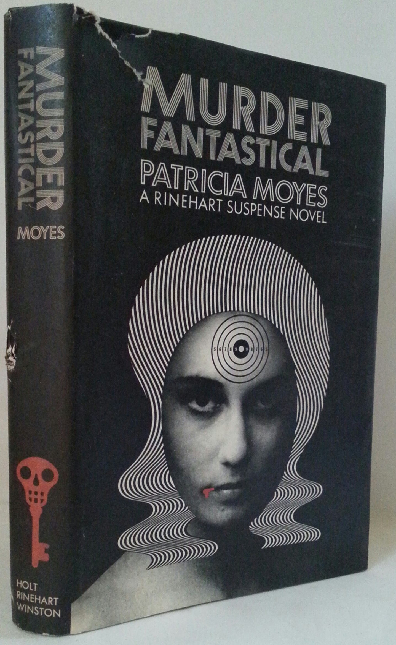

Moyes, Patricia
Murder fantastical
Holt, Rinehart and Winston (USA) (1967) first printing

Суперобложки первых изданий книги

