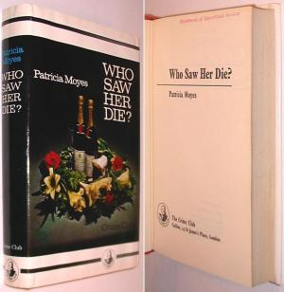
Patricia Moyes
Who saw her die?
Collins Crime Club (UK), 1970 first edition

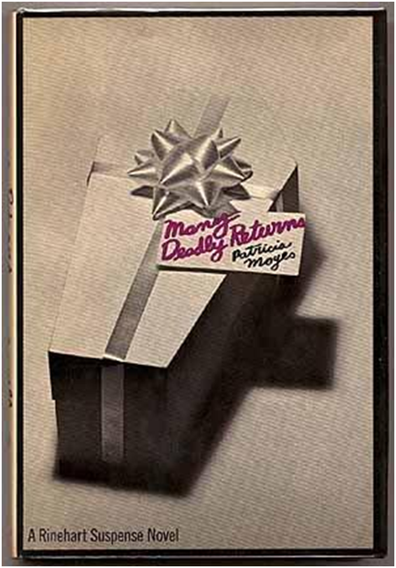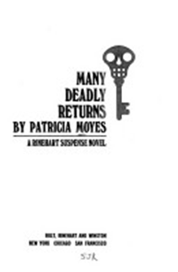

Patricia Moyes
Many deadly returns
Holt, Rinehart and Winston (USA), 1970 first edition

Обложки первых изданий книги

