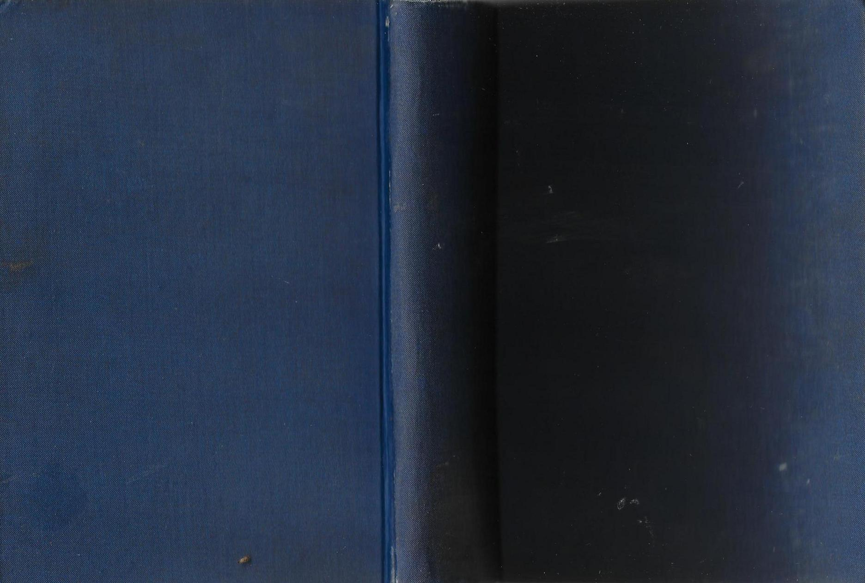

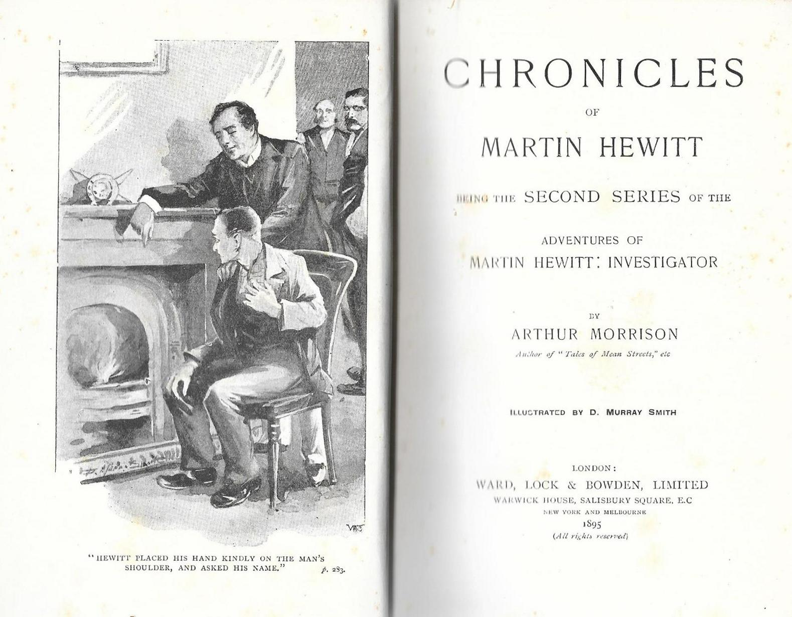

Morrison, Arthur

Chronicles of Martin Hewitt
Ward, Lock and Bowden, Limited (UK) (1895) first printing

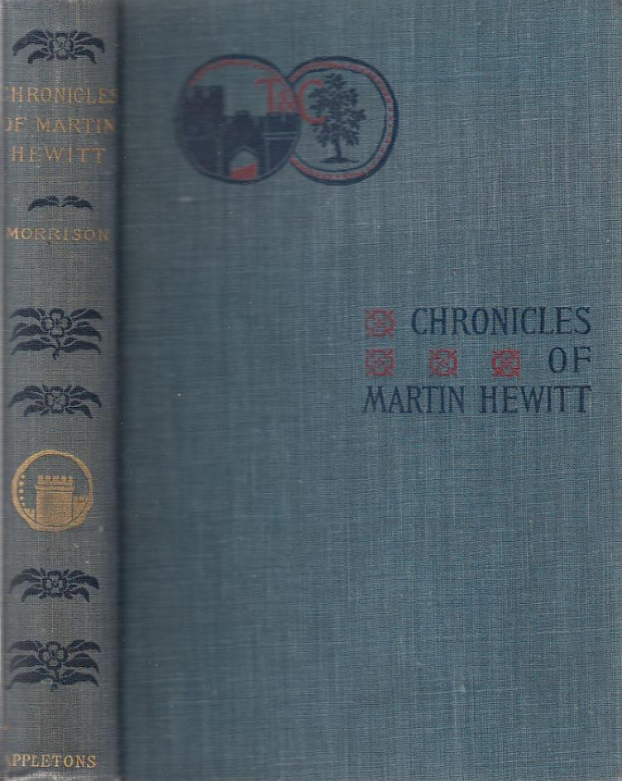

Morrison, Arthur

Chronicles of Martin Hewitt
D. Appleton, (USA) (1896) first printing

Обложки и титульный лист первых изданий сборника

