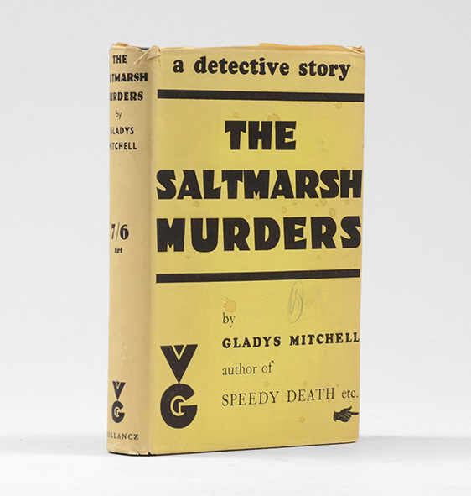

Mitchell G. The Saltmarsh murders. London: Victor Gollancz Ltd., 1932

