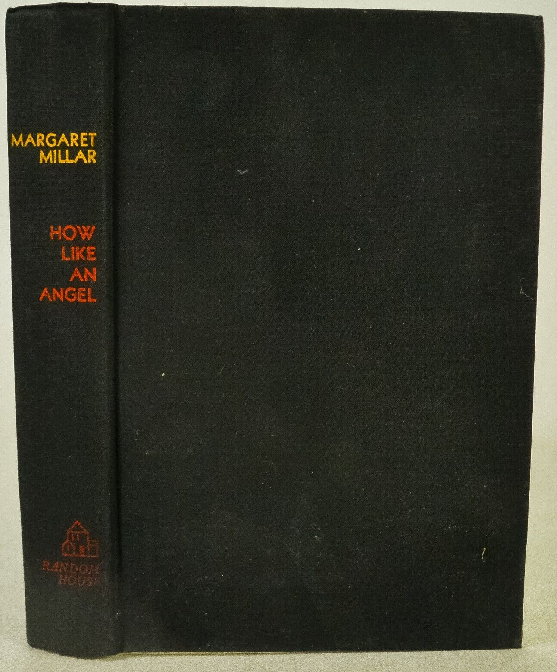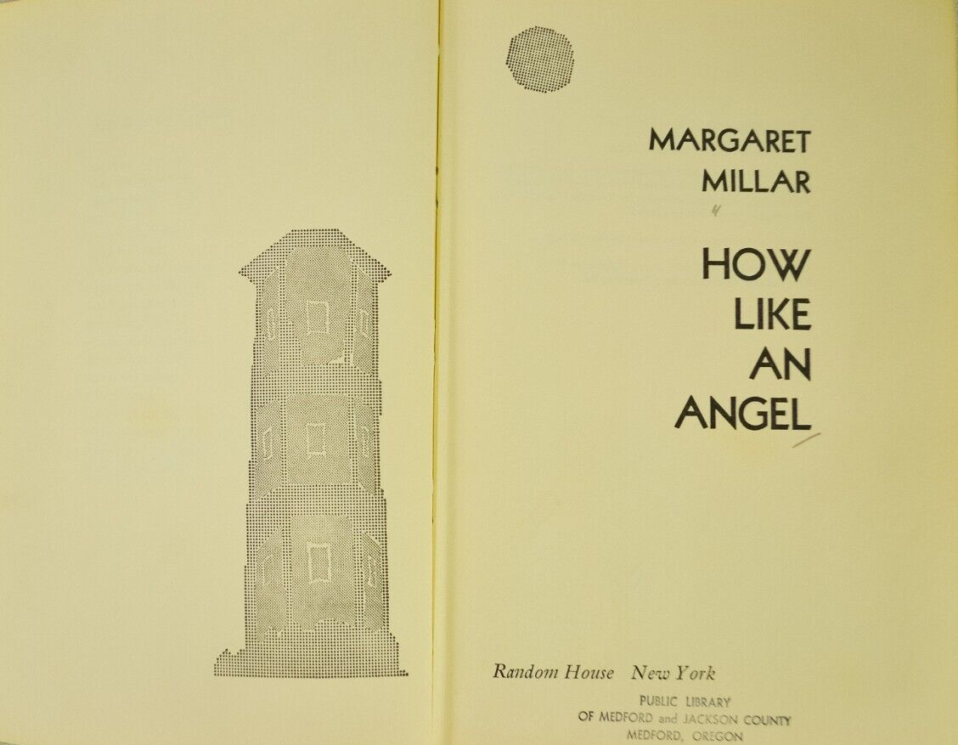

Millar, Margaret
How like an angel
Random House (USA) (1962) first printing

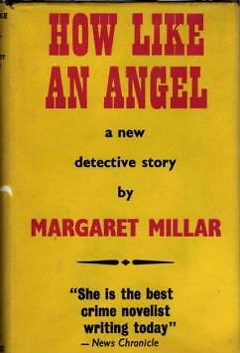

Millar, Margaret
How like an angel
Victor Gollancz Ltd (UK) (1962) first printing

Суперобложка и внешний вид первых изданий романа

