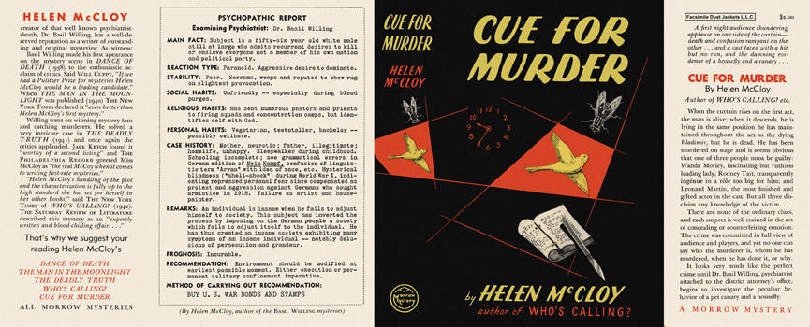

Dust jacket of first US edition

McCloy H. Cue for murder. New York: William Morrow, 1942

