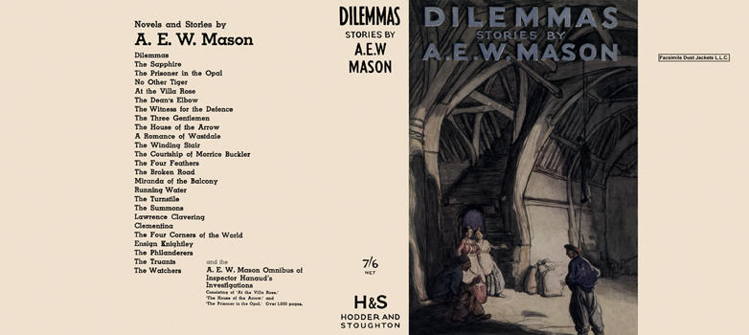



Mason, A. E. W.

Dilemmas
Hodder and Stoughton (UK), 1934
first printing

