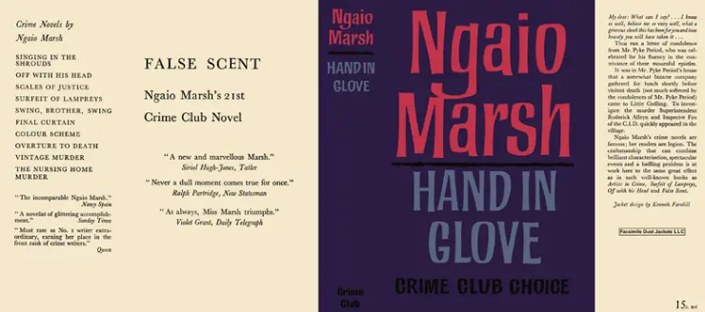

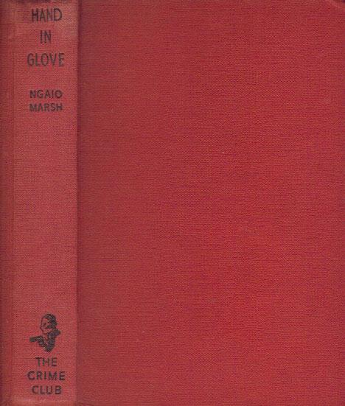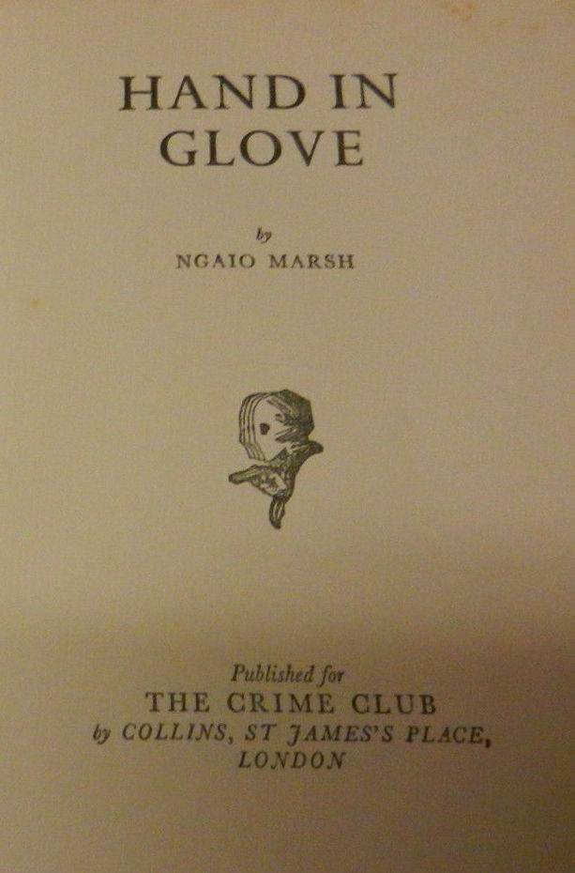

Marsh, Ngaio
Hand in glove
Collins The Crime Club (UK) (1962) first printing

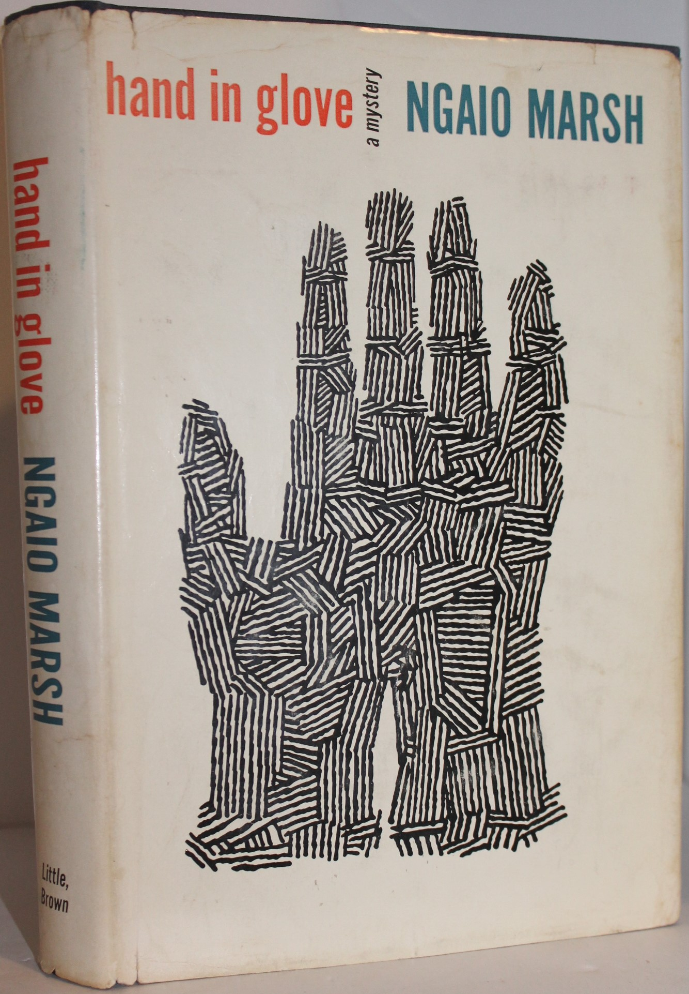

Marsh, Ngaio
Hand in glove
Little Brown (USA) (1962) first printing

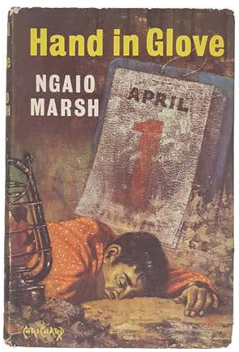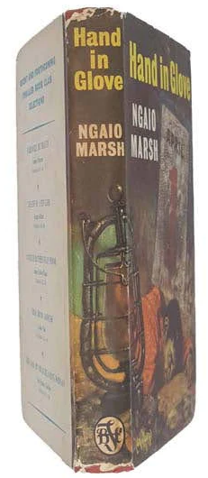

Marsh, Ngaio
Hand in glove
Thriller Book Club (UK) (1962) first printing

Суперобложки и внешний вид первых изданий романа

