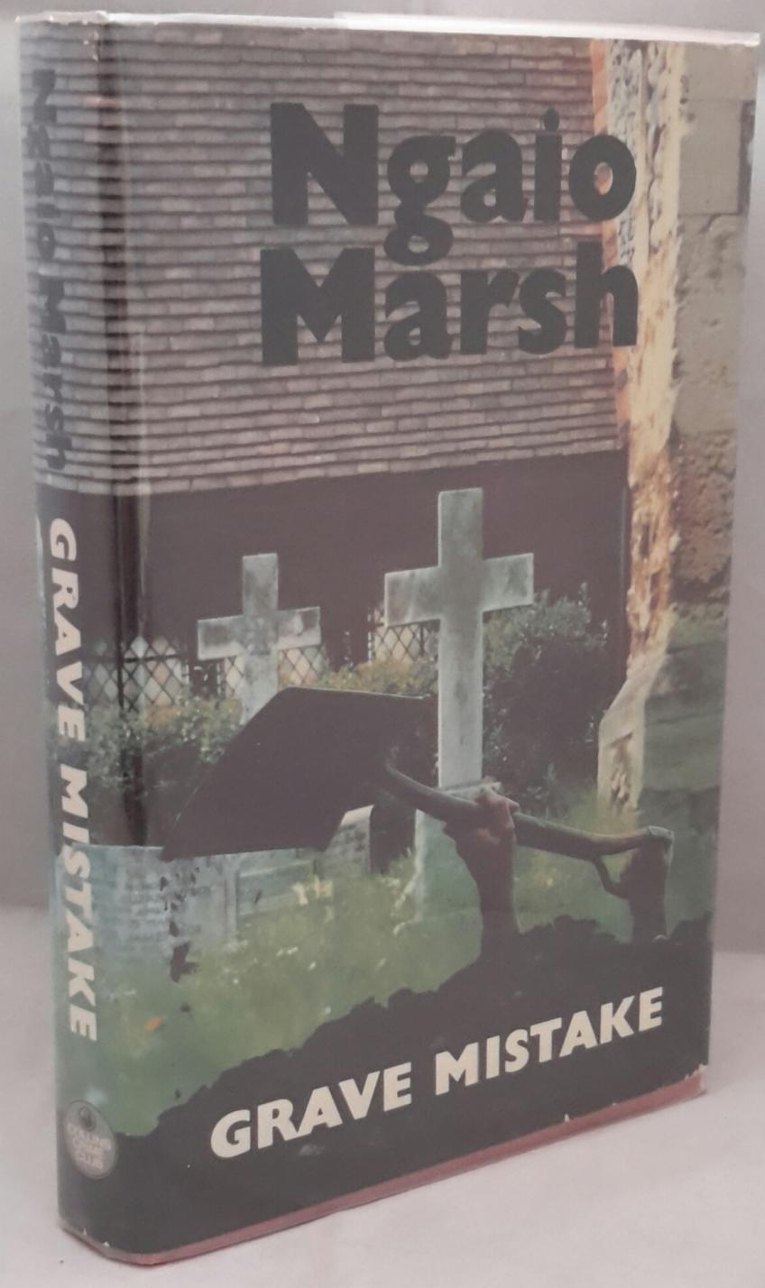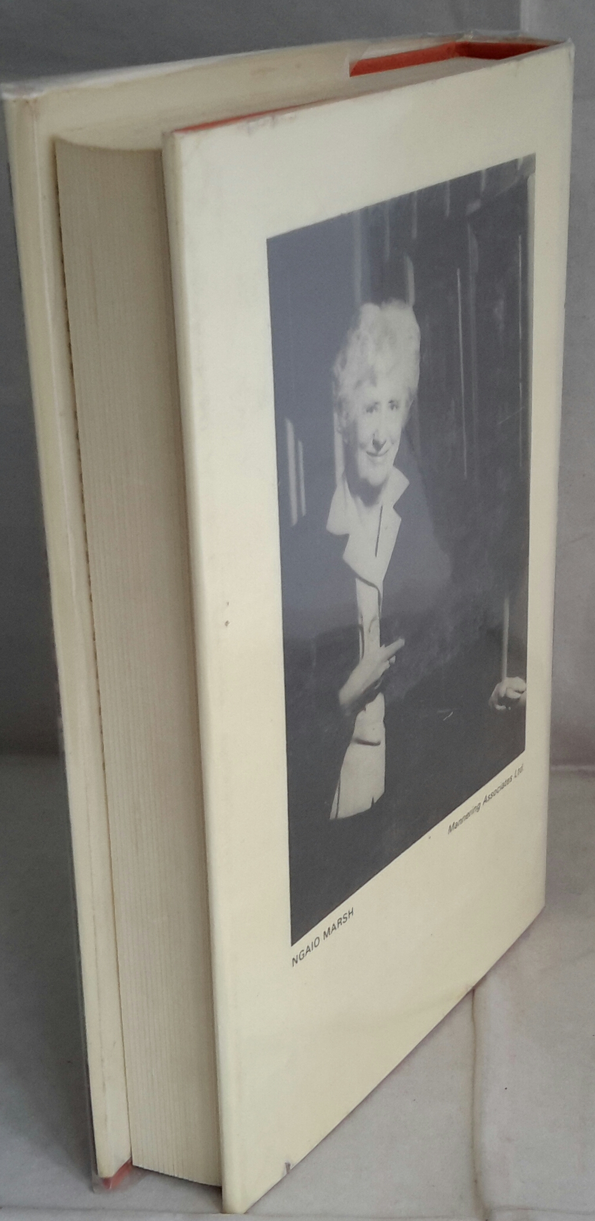

Marsh, Ngaio

Grave mistake
William Collins Sons and Co Ltd (UK) (1978) first edition

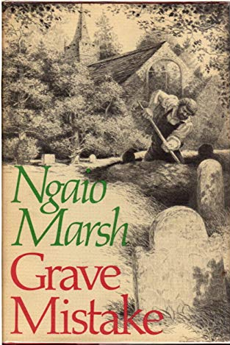

Marsh, Ngaio

Grave mistake
Little Brown & Co (USA) (1978) first edition

Внешний вид первых изданий романа

