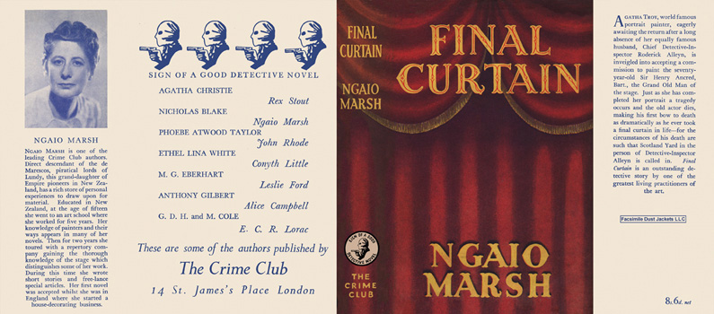

Marsh, Ngaio

Final Curtain
Collins The Crime Club (UK) (1947) first printing

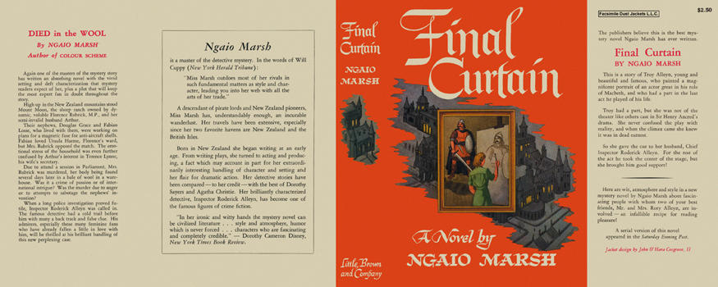

Marsh, Ngaio

Final Curtain
Little, Brown and Company (USA) (1947) first printing

Суперобложки первых изданий романа

