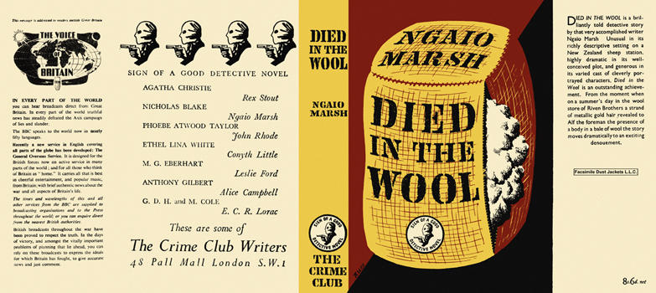

Marsh, Ngaio
Died in the wool
Collins The Crime Club (UK) (1945) first printing

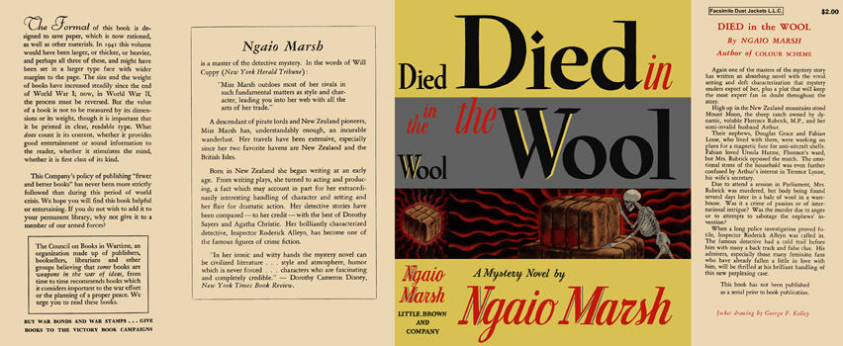

Marsh, Ngaio
Died in the wool
Little, Brown and Company (USA) (1945) first printing

Суперобложки первых изданий книги

