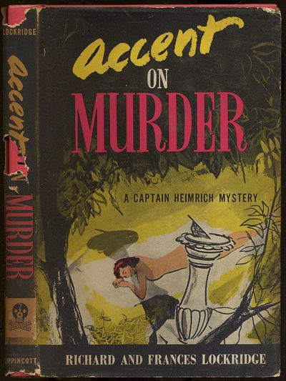

Richard and Francis Lockridge
Accent on murder
J. B. Lippincott Company (USA) (1958) first printing

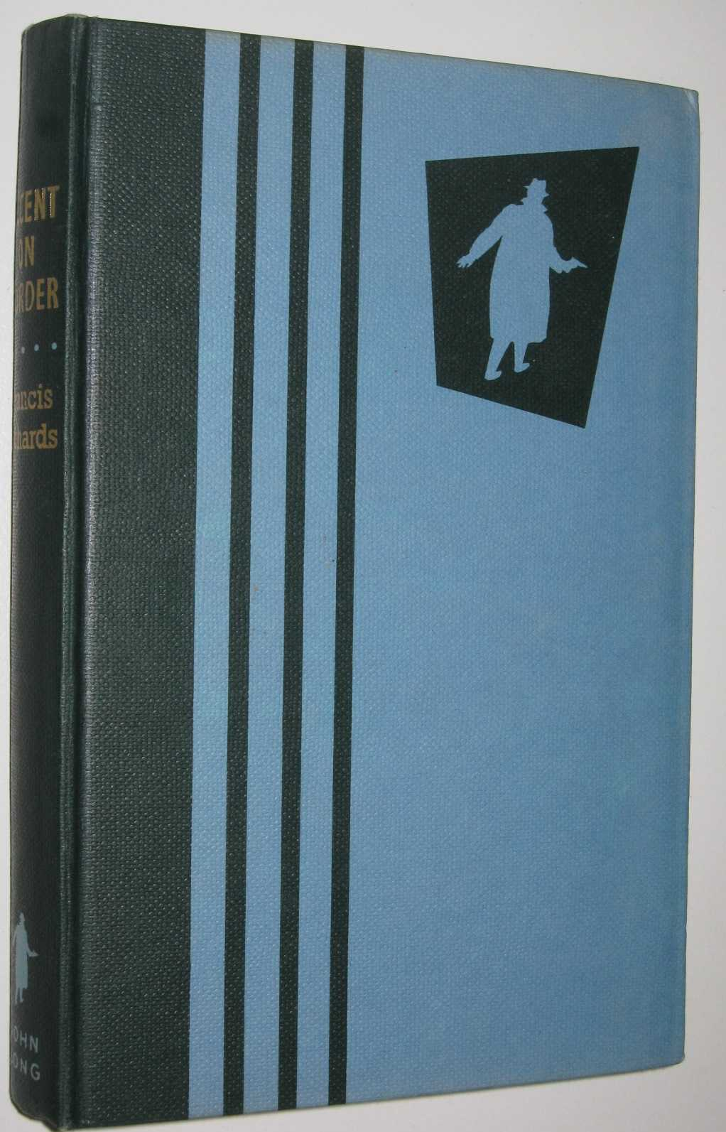

Lockridge, Frances Richard
Accent on murder
John Long (UK) (1960) first printing

Суперобложка и внешний вид первых изданий романа

