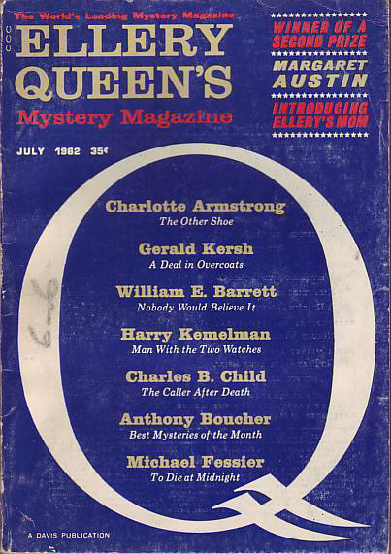

Ellery Queen’s Mystery Magazine [v40 #1, #224, July 1962]
  - 5 · Introducing Ellery’s Mom · Margaret Austin · nv
  - 23 · The Other Shoe · Charlotte Armstrong · ss
  - 36 · What Happened in Act One · William Bankier · ss
  - 44 · To Die at Midnight · Michael Fessier ·
  - 55 · Nobody Would Believe It · William E. Barrett · ss
  - 69 · An Accident of Time · Catharine Boyd · ss
  - 74 · Mystery Hardcovers of the Month · [Various] · br
  - 74 · Mystery Paperbacks of the Month · [Various] · br
  - 75 · Best Mysteries of the Month · Anthony Boucher · br
  - 76 · The Caller After Death [Chafik J. Chafik] · Charles B. Child ·
  - 89 · Go Play with Your Sister · Herb Goldstein · ss
  - 94 · A Time for Tea · Thomas P. Stone · ss
  - 100 · The Adventure of the Missing Prince [Schlock Homes] · Robert L. Fish · ss
  - 108 · A Deal in Overcoats [Karmesin] · Gerald Kersh ·
  - 120 · The Man with the Two Watches [Nicky Welt] · Harry Kemelman ·

Обложка журнала, в котором был напечатан рассказ

