Jerome K. Jerome

The street of the blank wall
I had turned off from the Edgware Road into a street leading west, the atmosphere of which had appealed to me. It was a place of quiet houses standing behind little gardens. They had the usual names printed on the stuccoed gateposts. The fading twilight was just sufficient to enable one to read them. There was a Laburnum Villa, and The Cedars, and a Cairngorm, rising to the height of three storeys, with a curious little turret that branched out at the top, and was crowned with a conical roof, so that it looked as if wearing a witch's hat. Especially when two small windows just below the eaves sprang suddenly into light, and gave one the feeling of a pair of wicked eyes suddenly flashed upon one.
The street curved to the right, ending in an open space through which passed a canal beneath a low arched bridge. There were still the same quiet houses behind their small gardens, and I watched for a while the lamplighter picking out the shape of the canal, that widened just above the bridge into a lake with an island in the middle. After that I must have wandered in a circle, for later on I found myself back in the same spot, though I do not suppose I had passed a dozen people on my way; and then I set to work to find my way back to Paddington.
I thought I had taken the road by which I had come, but the half light must have deceived me. Not that it mattered. They had a lurking mystery about them, these silent streets with their suggestion of hushed movement behind drawn curtains, of whispered voices behind the flimsy walls. Occasionally there would escape the sound of laughter, suddenly stifled as it seemed, and once the sudden cry of a child.
It was in a short street of semi-detached villas facing a high blank wall that, as I passed, I saw a blind move half-way up, revealing a woman's face. A gas lamp, the only one the street possessed, was nearly opposite. I thought at first it was the face of a girl, and then, as I looked again, it might have been the face of an old woman. One could not distinguish the colouring. In any case, the cold, blue gaslight would have made it seem pallid.
The remarkable feature was the eyes. It might have been, of course, that they alone caught the light and held it, rendering them uncannily large and brilliant. Or it might have been that the rest of the face was small and delicate, out of all proportion to them. She may have seen me, for the blind was drawn down again, and I passed on.
There was no particular reason why, but the incident lingered with me. The sudden raising of the blind, as of the curtain of some small theatre, the barely furnished room coming dimly into view, and the woman standing there, close to the footlights, as to my fancy it seemed. And then the sudden ringing down of the curtain before the play had begun. I turned at the corner of the street. The blind had been drawn up again, and I saw again the slight, girlish figure silhouetted against the side panes of the bow window.
At the same moment a man knocked up against me. It was not his fault. I had stopped abruptly, not giving him time to avoid me. We both apologised, blaming the darkness. It may have been my fancy, but I had the feeling that, instead of going on his way, he had turned and was following me. I waited till the next corner, and then swung round on my heel. But there was no sign of him, and after a while I found myself back in the Edgware Road.
Once or twice, in idle mood, I sought the street again, but without success; and the thing would, I expect, have faded from my memory, but that one evening, on my way home from Paddington, I came across the woman in the Harrow Road. There was no mistaking her. She almost touched me as she came out of a fishmonger's shop, and unconsciously, at the beginning, I found myself following her. This time I noticed the turnings, and five minutes' walking brought us to the street. Half a dozen times I must have been within a hundred yards of it. I lingered at the corner. She had not noticed me, and just as she reached the house a man came out of the shadows beyond the lamp-post and joined her.
I was due at a bachelor gathering that evening, and after dinner, the affair being fresh in my mind, I talked about it. I am not sure, but I think it was in connection with a discussion on Maeterlinck. It was that sudden lifting of the blind that had caught hold of me. As if, blundering into an empty theatre, I had caught a glimpse of some drama being played in secret. We passed to other topics, and when I was leaving a fellow guest asked me which way I was going. I told him, and, it being a fine night, he proposed that we should walk together. And in the quiet of Harley Street he confessed that his desire had not been entirely the pleasure of my company.
"It is rather curious," he said, "but today there suddenly came to my remembrance a case that for nearly eleven years I have never given a thought to. And now, on top of it, comes your description of that woman's face. I am wondering if it can be the same."
"It was the eyes," I said, "that struck me as so remarkable."
"It was the eyes that I chiefly remember her by," he replied. "Would you know the street again?"
We walked a little while in silence.
"It may seem, perhaps, odd to you," I answered, "but it would trouble me, the idea of any harm coming to her through me. What was the case?"
"You can feel quite safe on that point," he assured me. "I was her counsel—that is, if it is the same woman. How was she dressed?"
I could not see the reason for his question. He could hardly expect her to be wearing the clothes of eleven years ago.
"I don't think I noticed," I answered. "Some sort of a blouse, I suppose." And then I recollected. "Ah, yes, there was something uncommon," I added. "An unusually broad band of velvet, it looked like, round her neck."
"I thought so," he said. "Yes. It must be the same."
We had reached Marylebone Road, where our ways parted.
"I will look you up to-morrow afternoon, if I may," he said. "We might take a stroll round together."
He called on me about half-past five, and we reached the street just as the one solitary gas-lamp had been lighted. I pointed out the house to him, and he crossed over and looked at the number.
"Quite right," he said, on returning. "I made inquiries this morning. She was released six weeks ago on ticket-of-leave."
He took my arm.
"Not much use hanging about," he said. "The blind won't go up to-night. Rather a clever idea, selecting a house just opposite a lamp-post."
He had an engagement that evening; but later on he told me the story—that is, so far as he then knew it.

It was in the early days of the garden suburb movement. One of the first sites chosen was off the Finchley Road. The place was in the building, and one of the streets—Laleham Gardens—had only some half a dozen houses in it, all unoccupied save one. It was a lonely, loose end of the suburb, terminating suddenly in open fields. From the unfinished end of the road the ground sloped down somewhat steeply to a pond, and beyond that began a small wood. The one house occupied had been bought by a young married couple named Hepworth.
The husband was a good-looking, pleasant young fellow. Being clean-shaven, his exact age was difficult to judge. The wife, it was quite evident, was little more than a girl. About the man there was a suggestion of weakness. At least, that was the impression left on the mind of the house-agent. To-day he would decide, and to-morrow he changed his mind. Jetson, the agent, had almost given up hope of bringing off a deal. In the end it was Mrs. Hepworth who, taking the matter into her own hands, fixed upon the house in Laleham Gardens. Young Hepworth found fault with it on the ground of its isolation. He himself was often away for days at a time, travelling on business, and was afraid she would be nervous. He had been very persistent on this point; but in whispered conversations she had persuaded him out of his objection. It was one of those pretty, fussy little houses; and it seemed to have taken her fancy. Added to which, according to her argument, it was just within their means, which none of the others were. Young Hepworth may have given the usual references, but if so they were never taken up. The house was sold on the company's usual terms. The deposit was paid by a cheque, which was duly cleared, and the house itself was security for the rest. The company's solicitor, with Hepworth's consent, acted for both parties.
It was early in June when the Hepworths moved in. They furnished only one bedroom; and kept no servant, a charwoman coming in every morning and going away about six in the evening. Jetson was their nearest neighbour. His wife and daughters called on them, and confess to have taken a liking to them both. Indeed, between one of the Jetson girls, the youngest, and Mrs. Hepworth there seems to have sprung up a close friendship. Young Hepworth, the husband, was always charming, and evidently took great pains to make himself agreeable. But with regard to him they had the feeling that he was never altogether at his ease. They described him—though that, of course, was after the event—as having left upon them the impression of a haunted man.
There was one occasion in particular. It was about ten o'clock. The Jetsons had been spending the evening with the Hepworths, and were just on the point of leaving, when there came a sudden, clear knock at the door. It turned out to be Jetson's foreman, who had to leave by an early train in the morning, and had found that he needed some further instructions. But the terror in Hepworth's face was unmistakable. He had turned a look towards his wife that was almost of despair; and it had seemed to the Jetsons—or, talking it over afterwards, they may have suggested the idea to each other—that there came a flash of contempt into her eyes, though it yielded the next instant to an expression of pity. She had risen, and already moved some steps towards the door, when young Hepworth had stopped her, and gone out himself. But the curious thing was that, according to the foreman's account, Hepworth never opened the front door, but came upon him stealthily from behind. He must have slipped out by the back and crept round the house.
The incident had puzzled the Jetsons, especially that involuntary flash of contempt that had come into Mrs. Hepworth's eyes. She had always appeared to adore her husband, and of the two, if possible, to be the one most in love with the other. They had no friends or acquaintances except the Jetsons. No one else among their neighbours had taken the trouble to call on them, and no stranger to the suburb had, so far as was known, ever been seen in Laleham Gardens.
Until one evening a little before Christmas.
Jetson was on his way home from his office in the Finchley Road. There had been a mist hanging about all day, and with nightfall it had settled down into a whitish fog. Soon after leaving the Finchley Road, Jetson noticed in front of him a man wearing a long, yellow mackintosh, and some sort of soft felt hat. He gave Jetson the idea of being a sailor; it may have been merely the stiff, serviceable mackintosh. At the corner of Laleham Gardens the man turned, and glanced up at the name upon the lamp-post, so that Jetson had a full view of him. Evidently it was the street for which he was looking. Jetson, somewhat curious, the Hepworths' house being still the only one occupied, paused at the corner, and watched. The Hepworths' house was, of course, the only one in the road that showed any light. The man, when he came to the gate, struck a match for the purpose of reading the number. Satisfied it was the house he wanted, he pushed open the gate and went up the path.
But, instead of using the bell or knocker, Jetson was surprised to hear him give three raps on the door with his stick. There was no answer, and Jetson, whose interest was now thoroughly aroused, crossed to the other corner, from where he could command a better view. Twice the man repeated his three raps on the door, each time a little louder, and the third time the door was opened. Jetson could not tell by whom, for whoever it was kept behind it.
He could just see one wall of the passage, with a pair of old naval cutlasses crossed above the picture of a three-masted schooner that he knew hung there. The door was opened just sufficient, and the man slipped in, and the door was closed behind him. Jetson had turned to continue his way, when the fancy seized him to give one glance back. The house was in complete darkness, though a moment before Jetson was positive there had been a light in the ground floor window.
It all sounded very important afterwards, but at the time there was nothing to suggest to Jetson anything very much out of the common. Because for six months no friend or relation had called to see them, that was no reason why one never should. In the fog, a stranger may have thought it simpler to knock at the door with his stick than to fumble in search of a bell. The Hepworths lived chiefly in the room at the back. The light in the drawing-room may have been switched off for economy's sake. Jetson recounted the incident on reaching home, not as anything remarkable, but just as one mentions an item of gossip. The only one who appears to have attached any meaning to the affair was Jetson's youngest daughter, then a girl of eighteen. She asked one or two questions about the man, and, during the evening, slipped out by herself and ran round to the Hepworths. She found the house empty. At all events, she could obtain no answer, and the place, back and front, seemed to her to be uncannily silent.
Jetson called the next morning, something of his daughter's uneasiness having communicated itself to him. Mrs. Hepworth herself opened the door to him. In his evidence at the trial, Jetson admitted that her appearance had startled him. She seems to have anticipated his questions by at once explaining that she had had news of an unpleasant nature, and had been worrying over it all night. Her husband had been called away suddenly to America, where it would be necessary for her to join him as soon as possible. She would come round to Jetson's office later in the day to make arrangements about getting rid of the house and furniture.
The story seemed to reasonably account for the stranger's visit, and Jetson, expressing his sympathy and promising all help in his power, continued his way to the office. She called in the afternoon and handed him over the keys, retaining one for herself. She wished the furniture to be sold by auction, and he was to accept almost any offer for the house. She would try and see him again before sailing; if not, she would write him with her address. She was perfectly cool and collected. She had called on his wife and daughters in the afternoon, and had wished them good-bye.
Outside Jetson's office she hailed a cab, and returned in it to Laleham Gardens to collect her boxes. The next time Jetson saw her she was in the dock, charged with being an accomplice in the murder of her husband.

The body had been discovered in a pond some hundred yards from the unfinished end of Laleham Gardens. A house was in course of erection on a neighbouring plot, and a workman, in dipping up a pail of water, had dropped in his watch. He and his mate, worrying round with a rake, had drawn up pieces of torn clothing, and this, of course, had led to the pond being properly dragged. Otherwise the discovery might never have been made.
The body, heavily weighted with a number of flat-irons fastened to it by a chain and padlock, had sunk deep into the soft mud, and might have remained there till it rotted. A valuable gold repeater, that Jetson remembered young Hepworth having told him had been a presentation to his father, was in its usual pocket, and a cameo ring that Hepworth had always worn on his third finger was likewise fished up from the mud. Evidently the murder belonged to the category of crimes passionel. The theory of the prosecution was that it had been committed by a man who, before her marriage, had been Mrs. Hepworth's lover.
The evidence, contrasted with the almost spiritually beautiful face of the woman in the dock, came as a surprise to everyone in court. Originally connected with an English circus troupe touring in Holland, she appears, about seventeen, to have been engaged as a "song and dance artiste" at a particularly shady cafe chantant in Rotterdam, frequented chiefly by sailors. From there a man, an English sailor known as Charlie Martin, took her away, and for some months she had lived with him at a small estaminet the other side of the river. Later, they left Rotterdam and came to London, where they took lodgings in Poplar, near to the docks.
It was from this address in Poplar that, some ten months before the murder, she had married young Hepworth. What had become of Martin was not known. The natural assumption was that, his money being exhausted, he had returned to his calling, though his name, for some reason, could not be found in any ship's list.
That he was one and the same with the man that Jetson had watched till the door of the Hepworths' house had closed upon him there could be no doubt. Jetson described him as a thick-set, handsome-looking man, with a reddish beard and moustache. Earlier in the day he had been seen at Hampstead, where he had dined at a small coffee-shop in the High Street. The girl who had waited on him had also been struck by the bold, piercing eyes and the curly red beard. It had been an off-time, between two and three, when he had dined there, and the girl admitted that she had found him a "pleasant-spoken gentleman," and "inclined to be merry." He had told her that he had arrived in England only three days ago, and that he hoped that evening to see his sweetheart. He had accompanied the words with a laugh, and the girl thought—though, of course, this may have been after-suggestion—that an ugly look followed the laugh.
One imagines that it was this man's return that had been the fear constantly haunting young Hepworth. The three raps on the door, it was urged by the prosecution, was a pre-arranged or pre-understood signal, and the door had been opened by the woman. Whether the husband was in the house, or whether they waited for him, could not be said. He had been killed by a bullet entering through the back of the neck; the man had evidently come prepared.
Ten days had elapsed between the murder and the finding of the body, and the man was never traced. A postman had met him coming from the neighbourhood of Laleham Gardens at about half-past nine. In the fog, they had all but bumped into one another, and the man had immediately turned away his face.
About the soft felt hat there was nothing to excite attention, but the long, stiff, yellow mackintosh was quite unusual. The postman had caught only a momentary glimpse of the face, but was certain it was clean shaven. This made a sensation in court for the moment, but only until the calling of the next witness. The charwoman usually employed by the Hepworths had not been admitted to the house on the morning of Mrs. Hepworth's departure. Mrs. Hepworth had met her at the door and paid her a week's money in lieu of notice, explaining to her that she would not be wanted any more. Jetson, thinking he might possibly do better by letting the house furnished, had sent for this woman, and instructed her to give the place a thorough cleaning. Sweeping the carpet in the dining-room with a dustpan and brush, she had discovered a number of short red hairs. The man, before leaving the house, had shaved himself.
That he had still retained the long, yellow mackintosh may have been with the idea of starting a false clue. Having served its purpose, it could be discarded. The beard would not have been so easy. What roundabout way he may have taken one cannot say, but it must have been some time during the night or early morning that he reached young Hepworth's office in Fenchurch Street. Mrs. Hepworth had evidently provided him with the key.
There he seems to have hidden the hat and mackintosh and to have taken in exchange some clothes belonging to the murdered man. Hepworth's clerk, Ellenby, an elderly man—of the type that one generally describes as of gentlemanly appearance—was accustomed to his master being away unexpectedly on business, which was that of a ships' furnisher. He always kept an overcoat and a bag ready packed in the office. Missing them, Ellenby had assumed that his master had been called away by an early train. He would have been worried after a few days, but that he had received a telegram—as he then supposed from his master—explaining that young Hepworth had gone to Ireland and would be away for some days. It was nothing unusual for Hepworth to be absent, superintending the furnishing of a ship, for a fortnight at a time, and nothing had transpired in the office necessitating special instructions. The telegram had been handed in at Charing Cross, but the time chosen had been a busy period of the day, and no one had any recollection of the sender. Hepworth's clerk unhesitatingly identified the body as that of his employer, for whom it was evident that he had entertained a feeling of affection. About Mrs. Hepworth he said as little as he could. While she was awaiting her trial it had been necessary for him to see her once or twice with reference to the business. Previous to this, he knew nothing about her.
The woman's own attitude throughout the trial had been quite unexplainable. Beyond agreeing to a formal plea of "Not guilty," she had made no attempt to defend herself. What little assistance her solicitors had obtained had been given them, not by the woman herself, but by Hepworth's clerk, more for the sake of his dead master than out of any sympathy towards the wife. She herself appeared utterly indifferent. Only once had she been betrayed into a momentary emotion. It was when her solicitors were urging her almost angrily to give them some particulars upon a point they thought might be helpful to her case.
"He's dead!" she had cried out almost with a note of exultation. "Dead! Dead! What else matters?"
The next moment she had apologised for her outburst.
"Nothing can do any good," she had said. "Let the thing take its course."
It was the astounding callousness of the woman that told against her both with the judge and the jury. That shaving in the dining-room, the murdered man's body not yet cold! It must have been done with Hepworth's safety-razor. She must have brought it down to him, found him a looking-glass, brought him soap and water and a towel, afterwards removing all traces. Except those few red hairs that had clung, unnoticed, to the carpet. That nest of flat-irons used to weight the body! It must have been she who had thought of them. The idea would never have occurred to a man. The chain and padlock with which to fasten them. She only could have known that such things were in the house. It must have been she who had planned the exchange of clothes in Hepworth's office, giving him the key. She it must have been who had thought of the pond, holding open the door while the man had staggered out under his ghastly burden; waited, keeping watch, listening to hear the splash.
Evidently it had been her intention to go off with the murderer—to live with him! That story about America. If all had gone well, it would have accounted for everything. After leaving Laleham Gardens she had taken lodgings in a small house in Kentish Town under the name of Howard, giving herself out to be a chorus singer, her husband being an actor on tour. To make the thing plausible, she had obtained employment in one of the pantomimes. Not for a moment had she lost her head. No one had ever called at her lodgings, and there had come no letters for her. Every hour of her day could be accounted for. Their plans must have been worked out over the corpse of her murdered husband. She was found guilty of being an "accessory after the fact," and sentenced to fifteen years' penal servitude.
That brought the story up to eleven years ago. After the trial, interested in spite of himself, my friend had ferreted out some further particulars. Inquiries at Liverpool had procured him the information that Hepworth's father, a shipowner in a small way, had been well known and highly respected. He was retired from business when he died, some three years previous to the date of the murder. His wife had survived him by only a few months. Besides Michael, the murdered son, there were two other children—an elder brother, who was thought to have gone abroad to one of the colonies, and a sister who had married a French naval officer. Either they had not heard of the case or had not wished to have their names dragged into it. Young Michael had started life as an architect, and was supposed to have been doing well, but after the death of his parents had disappeared from the neighbourhood, and, until the trial, none of his acquaintances up North ever knew what had become of him.
But a further item of knowledge that my friend's inquiries had elicited had somewhat puzzled him. Hepworth's clerk, Ellenby, had been the confidential clerk of Hepworth's father! He had entered the service of the firm as a boy; and when Hepworth senior retired, Ellenby—with the old gentleman's assistance—had started in business for himself as a ships' furnisher! Nothing of all this came out at the trial. Ellenby had not been cross-examined. There was no need for it. But it seemed odd, under all the circumstances, that he had not volunteered the information. It may, of course, have been for the sake of the brother and sister. Hepworth is a common enough name in the North. He may have hoped to keep the family out of connection with the case.
As regards the woman, my friend could learn nothing further beyond the fact that, in her contract with the music-hall agent in Rotterdam, she had described herself as the daughter of an English musician, and had stated that both her parents were dead. She may have engaged herself without knowing the character of the hall, and the man, Charlie Martin, with his handsome face and pleasing sailor ways, and at least an Englishman, may have seemed to her a welcome escape.
She may have been passionately fond of him, and young Hepworth—crazy about her, for she was beautiful enough to turn any man's head—may in Martin's absence have lied to her, told her he was dead—lord knows what!—to induce her to marry him. The murder may have seemed to her a sort of grim justice.
But even so, her cold-blooded callousness was surely abnormal! She had married him, lived with him for nearly a year. To the Jetsons she had given the impression of being a woman deeply in love with her husband. It could not have been mere acting kept up day after day.
"There was something else." We were discussing the case in my friend's chambers. His brief of eleven years ago was open before him. He was pacing up and down with his hands in his pockets, thinking as he talked. "Something that never came out. There was a curious feeling she gave me in that moment when sentence was pronounced upon her. It was as if, instead of being condemned, she had triumphed. Acting! If she had acted during the trial, pretended remorse, even pity, I could have got her off with five years. She seemed to be unable to disguise the absolute physical relief she felt at the thought that he was dead, that his hand would never again touch her. There must have been something that had suddenly been revealed to her, something that had turned her love to hate.
"There must be something fine about the man, too." That was another suggestion that came to him as he stood staring out of the window across the river. "She's paid and has got her receipt, but he is still 'wanted.' He is risking his neck every evening he watches for the raising of that blind."
His thought took another turn.
"Yet how could he have let her go through those ten years of living death while he walked the streets scot free? Some time during the trial—the evidence piling up against her day by day—why didn't he come forward, if only to stand beside her? Get himself hanged, if only out of mere decency?"
He sat down, took the brief up in his hand without looking at it.
"Or was that the reward that she claimed? That he should wait, keeping alive the one hope that would make the suffering possible to her? Yes," he continued, musing, "I can see a man who cared for a woman taking that as his punishment."
Now that his interest in the case had been revived he seemed unable to keep it out of his mind. Since our joint visit I had once or twice passed through the street by myself, and on the last occasion had again seen the raising of the blind. It obsessed him—the desire to meet the man face to face. A handsome, bold, masterful man, he conceived him. But there must be something more for such a woman to have sold her soul—almost, one might say—for the sake of him.
There was just one chance of succeeding. Each time he had come from the direction of the Edgware Road. By keeping well out of sight at the other end of the street, and watching till he entered it, one might time oneself to come upon him just under the lamp. He would hardly be likely to turn and go back; that would be to give himself away. He would probably content himself with pretending to be like ourselves, merely hurrying through, and in his turn watching till we had disappeared.
Fortune seemed inclined to favour us. About the usual time the blind was gently raised, and very soon afterwards there came round the corner the figure of a man. We entered the street ourselves a few seconds later, and it seemed likely that, as we had planned, we should come face to face with him under the gaslight. He walked towards us, stooping and with bent head. We expected him to pass the house by. To our surprise he stopped when he came to it, and pushed open the gate. In another moment we should have lost all chance of seeing anything more of him except his bent back. With a couple of strides my friend was behind him. He laid his hand on the man's shoulder and forced him to turn round. It was an old, wrinkled face with gentle, rather watery eyes.
We were both so taken aback that for a moment we could say nothing. My friend stammered out an apology about having mistaken the house, and rejoined me. At the corner we burst out laughing almost simultaneously. And then my friend suddenly stopped and stared at me.
"Hepworth's old clerk!" he said. "Ellenby!"

It seemed to him monstrous. The man had been more than a clerk. The family had treated him as a friend. Hepworth's father had set him up in business. For the murdered lad he had had a sincere attachment; he had left that conviction on all of them. What was the meaning of it?
A directory was on the mantelpiece. It was the next afternoon. I had called upon him in his chambers. It was just an idea that came to me. I crossed over and opened it, and there was his name, "Ellenby and Co., Ships' Furnishers," in a court off the Minories.
Was he helping her for the sake of his dead master—trying to get her away from the man. But why? The woman had stood by and watched the lad murdered. How could he bear even to look on her again?
Unless there had been that something that had not come out—something he had learnt later—that excused even that monstrous callousness of hers.
Yet what could there be? It had all been so planned, so cold-blooded. That shaving in the dining-room! It was that seemed most to stick in his throat. She must have brought him down a looking-glass; there was not one in the room. Why couldn't he have gone upstairs into the bathroom, where Hepworth always shaved himself, where he would have found everything to his hand?
He had been moving about the room, talking disjointedly as he paced, and suddenly he stopped and looked at me.
"Why in the dining-room?" he demanded of me.
He was jingling some keys in his pocket. It was a habit of his when cross-examining, and I felt as if somehow I knew; and, without thinking—so it seemed to me—I answered him.
"Perhaps," I said, "it was easier to bring a razor down than to carry a dead man up."
He leant with his arms across the table, his eyes glittering with excitement.
"Can't you see it?" he said. "That little back parlour with its fussy ornaments. The three of them standing round the table, Hepworth's hands nervously clutching a chair. The reproaches, the taunts, the threats. Young Hepworth—he struck everyone as a weak man, a man physically afraid—white, stammering, not knowing which way to look. The woman's eyes turning from one to the other. That flash of contempt again—she could not help it—followed, worse still, by pity. If only he could have answered back, held his own! If only he had not been afraid! And then that fatal turning away with a sneering laugh one imagines, the bold, dominating eyes no longer there to cower him.
"That must have been the moment. The bullet, if you remember, entered through the back of the man's neck. Hepworth must always have been picturing to himself this meeting—tenants of garden suburbs do not carry loaded revolvers as a habit—dwelling upon it till he had worked himself up into a frenzy of hate and fear. Weak men always fly to extremes. If there was no other way, he would kill him.
"Can't you hear the silence? After the reverberations had died away! And then they are both down on their knees, patting him, feeling for his heart. The man must have gone down like a felled ox; there were no traces of blood on the carpet. The house is far from any neighbour; the shot in all probability has not been heard. If only they can get rid of the body! The pond—not a hundred yards away!"
He reached for the brief, still lying among his papers; hurriedly turned the scored pages.
"What easier? A house being built on the very next plot. Wheelbarrows to be had for the taking. A line of planks reaching down to the edge. Depth of water where the body was discovered four feet six inches. Nothing to do but just tip up the barrow.
"Think a minute. Must weigh him down, lest he rise to accuse us; weight him heavily, so that he will sink lower and lower into the soft mud, lie there till he rots.
"Think again. Think it out to the end. Suppose, in spite of all our precautions, he does rise? Suppose the chain slips? The workmen going to and fro for water—suppose they do discover him?
"He is lying on his back, remember. They would have turned him over to feel for his heart. Have closed his eyes, most probably, not liking their stare.
"It would be the woman who first thought of it. She has seen them both lying with closed eyes beside her. It may have always been in her mind, the likeness between them. With Hepworth's watch in his pocket, Hepworth's ring on his finger! If only it was not for the beard—that fierce, curling, red beard!
"They creep to the window and peer out. Fog still thick as soup. Not a soul, not a sound. Plenty of time.
"Then to get away, to hide till one is sure. Put on the mackintosh. A man in a yellow mackintosh may have been seen to enter; let him be seen to go away. In some dark corner or some empty railway carriage take it off and roll it up. Then make for the office. Wait there for Ellenby. True as steel, Ellenby; good business man. Be guided by Ellenby."
He flung the brief from him with a laugh.
"Why, there's not a missing link!" he cried. "And to think that not a fool among us ever thought of it!"
"Everything fitting into its place," I suggested, "except young Hepworth. Can you see him, from your description of him, sitting down and coolly elaborating plans for escape, the corpse of the murdered man stretched beside him on the hearthrug?"
"No," he answered. "But I can see her doing it, a woman who for week after week kept silence while we raged and stormed at her, a woman who for three hours sat like a statue while old Cutbush painted her to a crowded court as a modern Jezebel, who rose up from her seat when that sentence of fifteen years' penal servitude was pronounced upon her with a look of triumph in her eyes, and walked out of court as if she had been a girl going to meet her lover.
"I'll wager," he added, "it was she who did the shaving. Hepworth would have cut him, even with a safety-razor."
"It must have been the other one, Martin," I said, "that she loathed. That almost exultation at the thought that he was dead," I reminded him.
"Yes," he mused. "She made no attempt to disguise it. Curious there having been that likeness between them." He looked at his watch. "Do you care to come with me?" he said.
"Where are you going?" I asked him.
"We may just catch him," he answered. "Ellenby and Co."

The office was on the top floor of an old-fashioned house in a cul-de-sac off the Minories. Mr. Ellenby was out, so the lanky office-boy informed us, but would be sure to return before evening; and we sat and waited by the meagre fire till, as the dusk was falling, we heard his footsteps on the creaking stairs.
He halted a moment in the doorway, recognising us apparently without surprise; and then, with a hope that we had not been kept waiting long, he led the way into an inner room.
"I do not suppose you remember me," said my friend, as soon as the door was closed. "I fancy that, until last night, you never saw me without my wig and gown. It makes a difference. I was Mrs. Hepworth's senior counsel."
It was unmistakable, the look of relief that came into the old, dim eyes. Evidently the incident of the previous evening had suggested to him an enemy.
"You were very good," he murmured. "Mrs. Hepworth was overwrought at the time, but she was very grateful, I know, for all your efforts."
I thought I detected a faint smile on my friend's lips.
"I must apologise for my rudeness to you of last night," he continued. "I expected, when I took the liberty of turning you round, that I was going to find myself face to face with a much younger man."
"I took you to be a detective," answered Ellenby, in his soft, gentle voice. "You will forgive me, I'm sure. I am rather short-sighted. Of course, I can only conjecture, but if you will take my word, I can assure you that Mrs. Hepworth has never seen or heard from the man Charlie Martin since the date of"—he hesitated a moment—"of the murder."
"It would have been difficult," agreed my friend, "seeing that Charlie Martin lies buried in Highgate Cemetery."
Old as he was, he sprang from his chair, white and trembling.
"What have you come here for?" he demanded.
"I took more than a professional interest in the case," answered my friend. "Ten years ago I was younger than I am now. It may have been her youth—her extreme beauty. I think Mrs. Hepworth, in allowing her husband to visit her—here where her address is known to the police, and watch at any moment may be set upon her—is placing him in a position of grave danger. If you care to lay before me any facts that will allow me to judge of the case, I am prepared to put my experience, and, if need be, my assistance, at her service."
His self-possession had returned to him.
"If you will excuse me," he said, "I will tell the boy that he can go."
We heard him, a moment later, turn the key in the outer door; and when he came back and had made up the fire, he told us the beginning of the story.
The name of the man buried in Highgate Cemetery was Hepworth, after all. Not Michael, but Alex, the elder brother.
From boyhood he had been violent, brutal, unscrupulous. Judging from Ellenby's story, it was difficult to accept him as a product of modern civilisation. Rather he would seem to have been a throwback to some savage, buccaneering ancestor. To expect him to work, while he could live in vicious idleness at somebody else's expense, was found to be hopeless. His debts were paid for about the third or fourth time, and he was shipped off to the Colonies. Unfortunately, there were no means of keeping him there. So soon as the money provided him had been squandered, he returned, demanding more by menaces and threats. Meeting with unexpected firmness, he seems to have regarded theft and forgery as the only alternative left to him. To save him from punishment and the family name from disgrace, his parents' savings were sacrificed. It was grief and shame that, according to Ellenby, killed them both within a few months of one another.
Deprived by this blow of what he no doubt had come to consider his natural means of support, and his sister, fortunately for herself, being well out of his reach, he next fixed upon his brother Michael as his stay-by. Michael, weak, timid, and not perhaps without some remains of boyish affection for a strong, handsome, elder brother, foolishly yielded. The demands, of course, increased, until, in the end, it came almost as a relief when the man's vicious life led to his getting mixed up with a crime of a particularly odious nature. He was anxious now for his own sake to get away, and Michael, with little enough to spare for himself, provided him with the means, on the solemn understanding that he would never return.
But the worry and misery of it all had left young Michael a broken man. Unable to concentrate his mind any longer upon his profession, his craving was to get away from all his old associations—to make a fresh start in life. It was Ellenby who suggested London and the ship furnishing business, where Michael's small remaining capital would be of service. The name of Hepworth would be valuable in shipping circles, and Ellenby, arguing this consideration, but chiefly with the hope of giving young Michael more interest in the business, had insisted that the firm should be Hepworth and Co.
They had not been started a year before the man returned, as usual demanding more money. Michael, acting under Ellenby's guidance, refused in terms that convinced his brother that the game of bullying was up. He waited a while, and then wrote pathetically that he was ill and starving. If only for the sake of his young wife, would not Michael come and see them?
This was the first they had heard of his marriage. There was just a faint hope that it might have effected a change, and Michael, against Ellenby's advice, decided to go. In a miserable lodging-house in the East End he found the young wife, but not his brother, who did not return till he was on the point of leaving. In the interval the girl seems to have confided her story to Michael.
She had been a singer, engaged at a music-hall in Rotterdam. There Alex Hepworth, calling himself Charlie Martin, had met her and made love to her. When he chose, he could be agreeable enough, and no doubt her youth and beauty had given to his protestations, for the time being, a genuine ring of admiration and desire. It was to escape from her surroundings, more than anything else, that she had consented. She was little more than a child, and anything seemed preferable to the nightly horror to which her life exposed her.
He had never married her. At least, that was her belief at the time. During his first drunken bout he had flung it in her face that the form they had gone through was mere bunkum. Unfortunately for her, this was a lie. He had always been coolly calculating. It was probably with the idea of a safe investment that he had seen to it that the ceremony had been strictly legal.
Her life with him, so soon as the first novelty of her had worn off, had been unspeakable. The band that she wore round her neck was to hide where, in a fit of savagery, because she had refused to earn money for him on the streets, he had tried to cut her throat. Now that she had got back to England she intended to leave him. If he followed and killed her she did not care.
It was for her sake that young Hepworth eventually offered to help his brother again, on the condition that he would go away by himself. To this the other agreed. He seems to have given a short display of remorse. There must have been a grin on his face as he turned away. His cunning eyes had foreseen what was likely to happen. The idea of blackmail was no doubt in his mind from the beginning. With the charge of bigamy as a weapon in his hand, he might rely for the rest of his life upon a steady and increasing income.
Michael saw his brother off as a second-class passenger on a ship bound for the Cape. Of course, there was little chance of his keeping his word, but there was always the chance of his getting himself knocked on the head in some brawl. Anyhow, he would be out of the way for a season, and the girl, Lola, would be left. A month later he married her, and four months after that received a letter from his brother containing messages to Mrs. Martin, "from her loving husband, Charlie," who hoped before long to have the pleasure of seeing her again.
Inquiries through the English Consul in Rotterdam proved that the threat was no mere bluff. The marriage had been legal and binding.
What happened on the night of the murder, was very much as my friend had reconstructed it. Ellenby, reaching the office at his usual time the next morning, had found Hepworth waiting for him. There he had remained in hiding until one morning, with dyed hair and a slight moustache, he had ventured forth.
Had the man's death been brought about by any other means, Ellenby would have counselled his coming forward and facing his trial, as he himself was anxious to do; but, viewed in conjunction with the relief the man's death must have been to both of them, that loaded revolver was too suggestive of premeditation. The isolation of the house, that conveniently near pond, would look as if thought of beforehand. Even if pleading extreme provocation, Michael escaped the rope, a long term of penal servitude would be inevitable.
Nor was it certain that even then the woman would go free. The murdered man would still, by a strange freak, be her husband; the murderer—in the eye of the law—her lover.
Her passionate will had prevailed. Young Hepworth had sailed for America. There he had no difficulty in obtaining employment—of course, under another name—in an architects office; and later had set up for himself. Since the night of the murder they had not seen each other till some three weeks ago.

I never saw the woman again. My friend, I believe, called on her. Hepworth had already returned to America, and my friend had succeeded in obtaining for her some sort of a police permit that practically left her free.
Sometimes of an evening I find myself passing through the street. And always I have the feeling of having blundered into an empty theatre—where the play is ended.

http://www.gutenberg.org/files/2023/2023-h/2023-h.htm

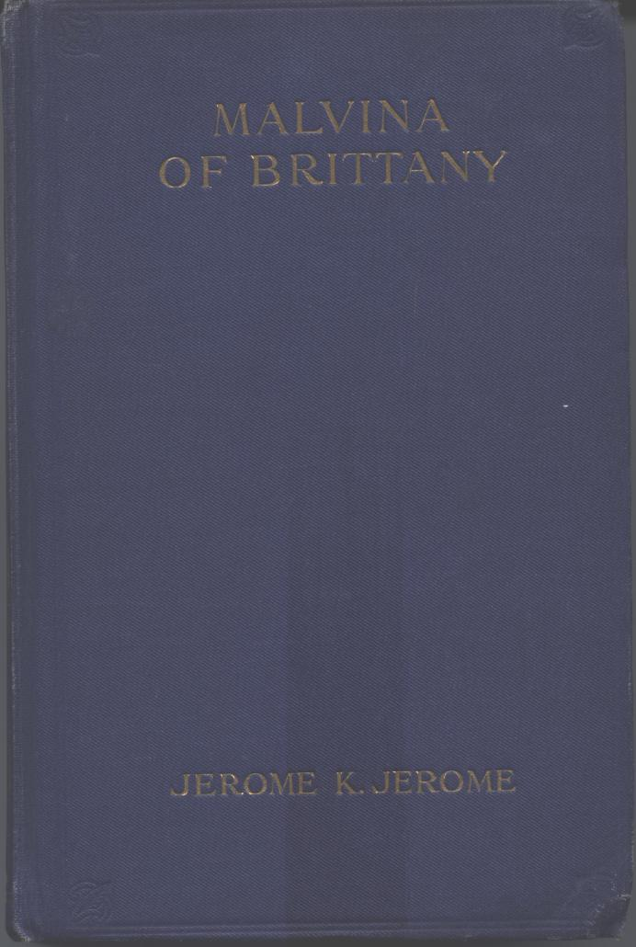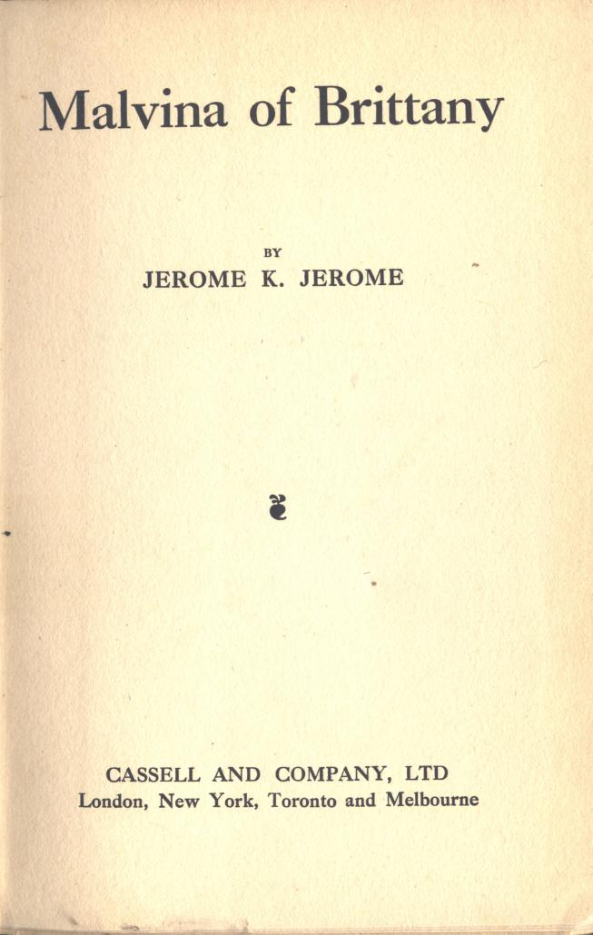

Malvina of Brittany. London, Cassell and Company, Limited, [1916]

CONTENTS

MALVINA OF BRITTANY
THE STREET OF THE BLANK WALL
HIS EVENING OUT
THE LESSON
SYLVIA OF THE LETTERS
THE FAWN GLOVES

PRINTED BY CASSELL & COMPANY, LIMITED, LA BELLE SAUVAGE, LONDON

