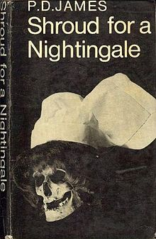

First UK edition

James P.D. Shroud for a Nightingale. London: Faber and Faber, 1971

