

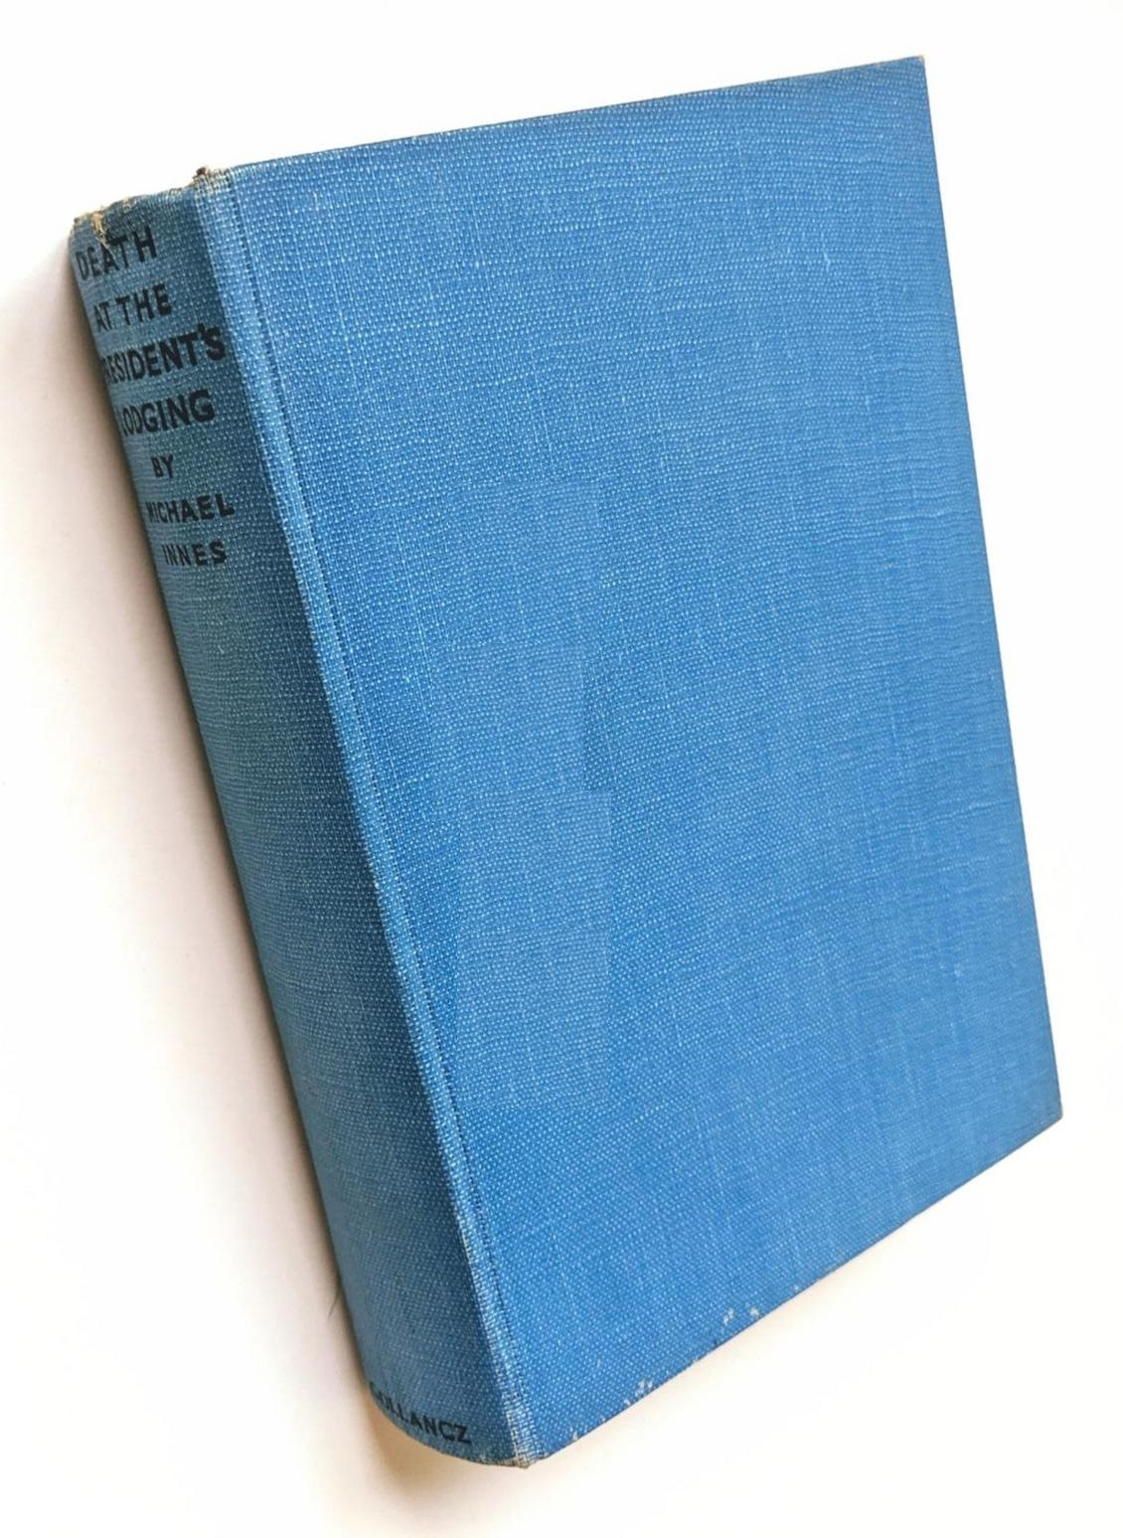

Innes, Michael

Death at the President's Lodging
V. G. Gollancz (UK) (1936) first printing

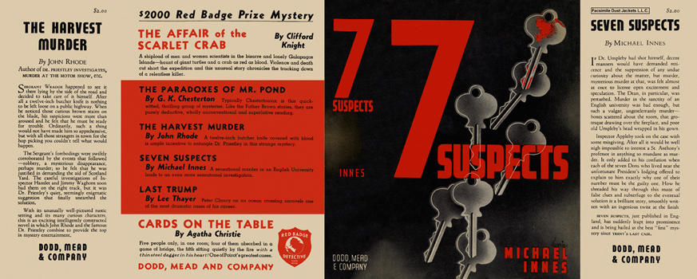

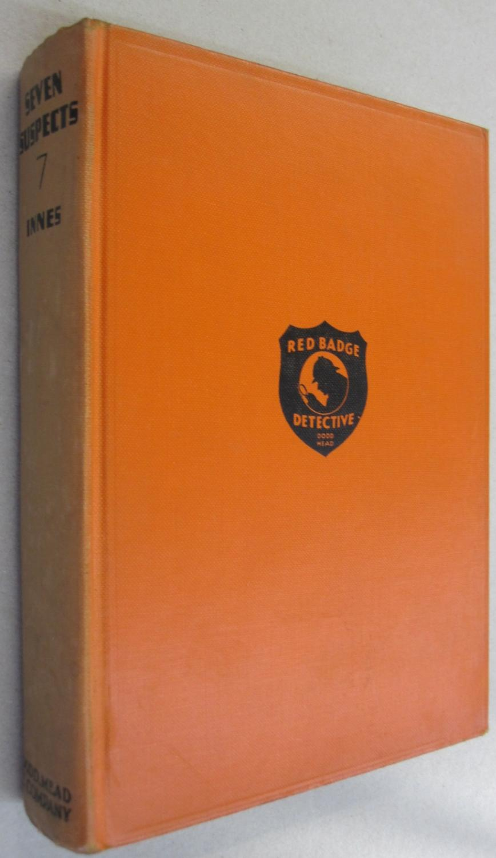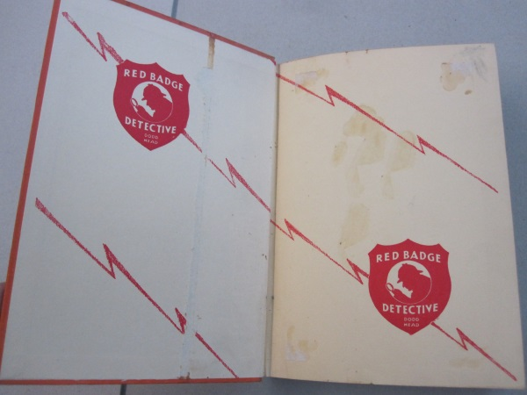

Innes, Michael
Seven suspects
Dodd, Mead and Company (USA) (1937) first printing.

Суперобложки и внешний вид первых изданий романа

